

学术型硕士研究生学位论文
ACADEMIC MASTER THESIS
（工学硕士Master of Engineering）

Climate Forecasting System Based on Deep Learning and Multi-Sensors

作者姓名 Uddin Sahab
学号 7420240311
导师 何刚
学科 Software Engineering
答辩委员会成员
评阅人

2025年12月

分类号： | 学校代码：10619
UDC： | 密级：

西南科技大学硕士学位论文
（理学硕士Master of Science）

Climate Forecasting System Based on Deep Learning and Multi-Sensors
作者姓名: UDDIN SAHAB

学科（专业）或领域名称：软件工程（人工智能）
指导教师姓名、职称：何刚(副教授)
校外指导教师姓名、职称：
学生所属学院名称：学校计算机科学与技术
论文答辩日期：2025年12月

A Thesis of Southwest University of Science and Technology for the Degree of Master
（Master of Natural Science）

Climate Forecasting System Based on Deep Learning and Multi-Sensors

Candidate：UDDIN SAHAB
Supervisor：何刚

12/ 2025

学位论文独创性声明

本人郑重声明：所呈交的学位论文是我个人在导师的指导下进行的研究工作及取得的研究成果。尽我所知，除了文中特别加以标注和致谢的地方外，论文中不包含其他人己经发表或撰写过的研究成果。与我一同工作的同志对本研究所做的任何贡献均己在论文中作了明确的说明，并表示了谢意。本人依法享有和承担由此论文所产生的权利和责任。



论文作者签名： 日期： 年 月 日
Graduate Signature: Date：

学位论文版权使用授权声明
本学位论文作者完全了解学校有关保存、使用学位论文的规定，即：研究生在西南科技大学学习和工作期间论文工作的知识产权单位属于西南科技大学。同意授权西南科技大学保留并向国家有关部门或机构送交该论文的印刷本和电子版本，允许该论文被查阅和借阅。同意授权西南科技大学可以将本学位论文的全部或部分内容编入有关数据库进行检索，可以采用影印、缩印、扫描或数字化等其他复制手段保存和汇编本学位论文。保密论文在解密后遵守此规定。

Authorization Statement for Copyright Use of Thesis
The author of this thesis fully understands the regulations of the university regarding the preservation and use of the thesis, that is, the intellectual property unit of the graduate student's thesis work during their study and work at Southwest University of Science and Technology belongs to Southwest University of Science and Technology. Agree to authorize Southwest University of Science and Technology to retain and submit the printed and electronic versions of the paper to relevant national departments or institutions and allow the paper to be viewed and borrowed. Agree to authorize Southwest University of Science and Technology to include all or part of the content of this thesis in relevant databases for retrieval, and to use other copying methods such as photocopying, reduction, scanning, or digitization to save and compile this thesis. Confidential papers shall comply with this regulation after decryption.

论文作者签名： 日 期： 年 月 日
Graduate Signature: Date：

指导导师签名： 日 期： 年 月 日
Supervisor Signature： Date：

摘要
气候变化已成为21世纪最严峻的全球挑战之一，影响着生态系统、农业和人类生活。因此，准确的气候预测对于灾害管理、环境规划和可持续发展至关重要。传统的预测方法往往难以处理庞大而复杂的数据集，限制了其捕捉气候变量长期变化模式的能力。
本研究提出了一种基于深度学习的气候预测系统，旨在提高预测的准确性和适应性。该系统整合了云量、湿度、温度、降水、风速、辐射和气压等多种环境因素。我们开发并比较了多种神经网络模型——RNN、GRU、BiLSTM、CNN-LSTM和LSTM——用于预测次日最高气温。
所提出的LSTM模型通过dropout正则化增强以减少过拟合，在所有模型中取得了最高的准确率。实验结果表明，该模型能够有效捕捉时间依赖性，并提供稳定的预测结果，其平均绝对误差（MAE）和均方根误差（RMSE）均低于传统方法。
该模型部署在一个基于 Flask 的 Web 应用程序中，该应用程序采用 HTML、CSS、Bootstrap 和 JavaScript 构建，界面简洁易用。用户可以输入实时数据或上传 CSV 文件，即时获取预测结果和可视化图表。
本研究表明，将多传感器数据与先进的 LSTM 架构和适当的数据预处理相结合，可以显著提高现代气候预测系统的准确性和易用性。所提出的方法弥合了研究与实际应用之间的差距，为智能气候分析和决策支持提供了一种切实可行的解决方案。
关键词：气候预测系统、深度学习、多传感器数据、温度预测、LSTM、Flask部署。

ABSTRACT
Climate change has become one of the most critical global challenges of the 21st century, affecting ecosystems, agriculture, and human life. Accurate climate forecasting is therefore essential for disaster management, environmental planning, and sustainable development. Traditional forecasting methods often struggle with large and complex datasets, limiting their ability to capture long-term patterns in climate variables.
This research presents a deep learning-based climate forecasting system designed to improve accuracy and adaptability. The system integrates multiple environmental factors such as humidity, temperature, precipitation, wind speed, radiation, and atmospheric pressure. Several neural network models RNN, GRU, BiLSTM, CNN–LSTM, and LSTM were developed and compared to predict next-day maximum temperature.
The proposed LSTM model, enhanced with dropout regularization to reduce overfitting, achieved the highest accuracy among all models. Experimental results show that it effectively captures temporal dependencies and provides stable predictions, with lower MAE and RMSE values than traditional approaches.
The model was deployed using a Flask-based web application, featuring an easy-to-use interface built with HTML, CSS, Bootstrap, and JavaScript. Users can input real-time data or upload CSV files to receive instant predictions and visualizations.
This study demonstrates that combining multi-sensor data with advanced LSTM architectures and proper data preprocessing can significantly enhance both the accuracy and usability of modern climate forecasting systems. The proposed approach bridges the gap between research and real-world application, offering a practical solution for intelligent climate analysis and decision support.
Keyword: Climate Forecasting System, Deep Learning, Multi-Sensor Data, Temperature Forecasting, LSTM, Flask Deployment.

Table of Contents
摘要 V
ABSTRACT VI
List of Figures X
List of Table XII
List of Abbreviations XIII
Chapter 1 Introduction 16
1.1 Background & Motivation 17
1.2 Problem Statement 18
1.3 Research Objectives 19
1.4 Research Questions 20
1.5 Scope of the Study 20
1.6 Thesis Contributions 21
1.7 Thesis Structure 22
Chapter 2 Literature Review 24
2.1 Climate Forecasting Approaches 24
2.1.1 Traditional Approaches 24
2.1.2 Machine Learning Approaches 24
2.1.3 Deep Learning Approaches 25
2.1.4 Integrated and Hybrid Systems 25
2.2 Deep Learning for Time-Series Forecasting 25
2.2.1 Recurrent Neural Networks (RNNs) 25
2.2.2 Long Short-Term Memory (LSTM) 26
2.2.3 Gated Recurrent Unit (GRU) 26
2.2.4 Bidirectional LSTM (BiLSTM) 26
2.2.5 Convolutional LSTM (CNN-LSTM) 26
2.2.6 Advantages of Deep Learning for Time-Series Data 26
2.3 Multi-Sensor Weather Data in Prediction 27
2.4 Traditional Forecasting vs. Deep Learning Models 28
2.5 Deployment Frameworks for ML Systems 29
2.6 Comparative Analysis of Existing Studies 31
2.7 Research Gap & Summary 32
Chapter 3 System Design 34
3.1 Overall System Concept 34
3.2 Dataset Description and Data Sources 35
3.3 Key Climate Variables Used 38
3.4 Data Preparation and Preprocessing 39
3.5 Sequence Construction and Leakage Control 40
3.6 Evaluation Metrics and Baselines 41
3.7 Deep Learning Models for Climate Prediction 42
3.7.1 Recurrent Neural Networks (RNNs) 42
3.7.2 Long Short-Term Memory (LSTM) 43
3.7.3 Gated Recurrent Unit (GRU) 45
3.7.4 Bidirectional Long Short-Term Memory (BiLSTM) 47
3.7.5 CNN–LSTM Hybrid Model 48
3.7 Model Training Setup 49
3.8 Implementation Details 50
Chapter 4 Research Methodology 52
4.1 Overview of Methodology 52
4.2 System Architecture & Flowchart 53
4.3 Data Preprocessing 56
4.4.1 Data Cleaning and Outlier Handling 56
4.4.2 Missing-Value Treatment 56
4.4.3 Time Alignment and Resampling 56
4.4.4 Feature scaling 57
4.4 Sequence Construction and Data Splitting 58
4.4.1 Sliding Window Generation 58
4.4.2 Chronological Train, Validation, and Test Split 58
4.4.3 Leakage Control and Sanity Checks 58
4.5 Model Architectures 58
4.5.1 RNN Configuration 58
4.5.2 LSTM configuration 60
4.5.3 GRU Configuration 62
4.5.4 BiLSTM Configuration 63
4.5.5 CNN–LSTM Configuration 64
4.6 Training Protocol 66
4.6.1 Optimizer and learning-rate schedule 66
4.6.2 Early stopping and epoch limits 66
4.6.3 Reproducibility 66
4.7 Hyperparameter Tuning 67
4.7.1 Search Space 67
4.7.2 Tuning Method and Selection Rule 68
4.7.3 Robustness Checks 68
4.9 Implementation Details 69
4.9.1 Libraries and Environment 69
4.9.2 Hardware and Runtime 70
4.9.3 Code Structure and Version Control 70
4.10 Deployment Methodology 72
4.10.1 Flask Backend Architecture 72
4.10.2 Login Interface and Authentication Table 73
4.10.3 API Endpoints and Input Validation 73
4.10.4 Model/Scaler Versioning and Logging 74
4.11 Web Interface Workflow 74
4.11.1 Frontend Stack 75
4.11.2 Manual Input and CSV Upload Flow 76
4.11.3 Visualizations 77
Chapter 5 Results and Discussion 78
5.1 Experimental Setup 78
5.2 Model Training and Performance Visualization 79
5.3 Model Performance Comparison 80
5.4 Error Analysis & Discussion 82
5.5 Model Evaluation and Comparison 84
5.6 Key Observations 85
5.7 Visualization of Results 86
Chapter 6 Conclusion and Future Work 88
6.1 Summary of Findings 88
6.2 Practical Implications 88
6.4 Future Improvements 89
Acknowledgement 91
References 92

List of Figures
Figure 1- 1 Climate Data Flow Overview 16
Figure 1- 2 Research Objectives Overview 18
Figure 1- 3 Research Motivation and Framework of the Climate Forecasting System 20

Figure 2- 1 General Workflow of Traditional Climate Forecasting Process 26

Figure 3- 1 Overall System Flow 34
Figure 3- 2 The feature distributions exhibit natural variability 35
Figure 3- 3 The correlation heatmap of climate variable 35
Figure 3- 4 The time-series of temperature and humidity 36
Figure 3- 5 The STL decomposition of mean temperature 36
Figure 3- 6 LSTM Cell Architecture Diagram 43
Figure 3- 7 Neural Network Architecture 44
Figure 3- 8 CNN-LSTM Model Architecture 48

Figure 4- 1 System Architecture of the Climate Forecasting System 52
Figure 4- 2 System Architecture Diagram 53
Figure 4- 3 System Architecture Flowchart 54
Figure 4- 4 RNN cells architectures diagrams 59
Figure 4- 5 Internal architecture of an LSTM 59
Figure 4- 6 Proposed LSTM Model architecture 60
Figure 4- 7 Internal architecture of a Gated Recurrent Unit 62
Figure 4- 8 The internal architecture of a BiLSTM 63
Figure 4- 9 CNN–LSTM Model Architecture 65
Figure 4- 10 Model Training and Evaluation Workflow 66
Figure 4- 11 Code Structure 70
Figure 4- 12 Login Interface and Authentication Table 72
Figure 4- 13 Workflow of User Interaction with the Web Interface 74
Figure 4- 14 User Login Interface 75
Figure 4- 15 User Input Interface 76
Figure 4- 16 Result Output and Location Map Interface 76
Figure 4- 17 Result Output and Location Map Interface 77

Figure 5- 1 Flask Web Interface Login Page (Development Mode) 78
Figure 5- 2 Training and Validation Loss (MSE) and MAE Curves of LSTM Model 79
Figure 5- 3 Combined Training and Validation Loss and MAE Curves Across Epochs 79
Figure 5- 4 RMSE Comparison among RNN, LSTM, GRU, BiLSTM, and CNN-LSTM 83
Figure 5- 5 Predicted vs. Actual Temperature (Test Set) 84
Figure 5- 6 LSTM Forecast – True vs. Predicted Temperature Over Time 86

List of Table
Table 2- 1 The Comparative Analysis of Previous Studies 31

Table 3- 1 Dataset Overview 39

Table 4- 1 Key Improvements Introduced in the Proposed Model 60

Table 5- 1 The quantitative comparison of all models is summarized 80

List of Abbreviations
AI  ANN  API  ARIMA  BiLSTM  BN  CNN– LSTM  CSV  DL  DNN  EMA  GUI  HTML  HTTP  I/O  IoT  JSON  KNN  MAE  MAPE  MLP  MSE  N/A  NLP  NOAA  PCA  R²  RAM  ReLU  RMSE  RLR  GAN  CNN  LSTM  GRU  SQL  SVM  TF  UI  URL  VS  W/m²  °C | Artificial Intelligence  Artificial Neural Network  Application Programming Interface  Auto-Regressive Integrated Moving Average  Bidirectional Long Short-Term Memory  Batch Normalization  Convolutional Neural Network combined with Long Short-Term Memory  Comma-Separated Values  Deep Learning  Deep Neural Network  Exponential Moving Average  Graphical User Interface  HyperText Markup Language  HyperText Transfer Protocol  Input / Output  Internet of Things  JavaScript Object Notation  K-Nearest Neighbors  Mean Absolute Error  Mean Absolute Percentage Error  Multi-Layer Perceptron  Mean Squared Error  Not Applicable  Natural Language Processing  National Oceanic and Atmospheric Administration  Principal Component Analysis  Coefficient of Determination  Random Access Memory  Rectified Linear Unit  Root Mean Squared Error  ReduceLROnPlateau (Learning Rate Scheduler)  Generative Adversarial Network  Convolutional Neural Network  Long Short-Term Memory  Gated Recurrent Unit  Structured Query Language  Support Vector Machine  TensorFlow  User Interface  Uniform Resource Locator  Visual Studio  Watts per Square Meter  Degree Celsius

Chapter 1 Introduction
Climate prediction is essential for protecting lives and livelihoods. Reliable forecasts help communities prepare for floods and heatwaves, guide farmers in irrigation and harvest planning, and support agencies in sustainable resource management. However, the climate system is highly variable and nonlinear. Traditional forecasting methods based on fixed equations and simple statistical trends often fail to capture long-range patterns and complex interactions among climate variables. As modern sensors produce more data, these limits become even clearer in real-world use.
This thesis develops a deep learning-based climate forecasting system that learns directly from multi-sensor data observations. The system brings together temperature, humidity, wind speed, precipitation, pressure, and radiation within a single, consistent time-series pipeline. Under identical settings, I implement and compare five neural network models Recurrent Neural Network, Long Short-Term Memory, Gated Recurrent Unit, Bidirectional LSTM, and Convolutional LSTM. Each model is trained with sliding-window sequences that preserve time order, allowing the networks to capture both short-term fluctuations and longer temporal dependencies that classical methods often miss. Across these tests, the LSTM model provides the most accurate and stable temperature forecasts.
The dataset is prepared carefully to ensure fair and reproducible evaluation. Records are cleaned, rare gaps are handled, and features are normalized and scaled. Sequence generation uses strictly forward-looking windows, and a held-out time split is reserved for final testing to avoid data leakage. All models are trained with a common optimizer and an early-stopping strategy to reduce overfitting. Performance is measured using Mean Absolute Error (MAE), Root Mean Square Error (RMSE), and the coefficient of determination (R²). This consistent protocol makes the comparison trustworthy and explains why LSTM is the preferred choice for this task.
Beyond modeling, the thesis delivers a complete engineering realization suitable for everyday use. The best LSTM model is deployed with a Flask backend and an interactive web interface built using HTML, CSS, Bootstrap, and JavaScript. Users can enter values manually or upload a CSV file for batch prediction. A simple admin panel supports registration and login; after signing in, users can generate maximum-temperature forecasts and view clear charts and numerical outputs. These design choices make the system easy to operate and interpret, even for non-experts.
The overall goal is to provide a practical tool that improves short-term temperature prediction while remaining transparent, reliable, and simple to extend. By pairing a rigorously evaluated LSTM model with an accessible web application, the system supports data-driven decisions in agriculture, disaster preparedness, and local climate services. This work shows how modern deep learning and careful data handling can raise forecast quality and turn raw sensor data into actionable climate insight.

1.1 Background & Motivation
Extreme weather events are becoming more frequent and severe, posing serious challenges to human life, agriculture, and infrastructure. Floods, heatwaves, and storms can destroy crops, disrupt transportation, and increase economic losses. Reliable short-term temperature forecasts play a critical role in minimizing these impacts. Accurate predictions help farmers plan irrigation and harvesting, enable cities to prepare for heat alerts, and allow disaster management teams to take timely action.
Traditional forecasting approaches, however, were not designed for the complexity of today’s data environment. Climate variables such as temperature, humidity, wind speed, and radiation are nonlinear, interdependent, and constantly changing over time. Models based solely on fixed equations or simple statistical correlations often fail to capture these dynamic relationships, leading to unstable or inaccurate forecasts especially under extreme conditions.
Deep learning provides a more adaptive and powerful alternative. Sequence-based neural architectures can directly learn from raw multi-sensor series data, identifying both short-term variations and long-term temporal dependencies without relying on manual feature engineering. Among these architectures, the Long Short-Term Memory (LSTM) network has shown strong ability to retain temporal context, making it well-suited for next-day temperature prediction where both precision and consistency are crucial.
The motivation for this research arises from three core needs.
First, to develop a leak-free and transparent data pipeline that transforms raw multi-sensor climate data into clean, consistent, and well-structured training and testing sets. This ensures fairness, reproducibility, and reliability throughout the experimental process.
Second, to design and optimize deep learning models, particularly LSTM, using robust regularization techniques such as dropout and early stopping to minimize overfitting and enhance generalization to unseen data.
Third, to create an interactive, lightweight web application that makes climate forecasting accessible beyond the research environment. Using a Flask-based framework, the system allows users to manually input parameters or upload CSV files and instantly view numerical forecasts, dynamic charts, and map-based visualizations.
Together, these objectives aim to produce an accurate, practical, and user-friendly forecasting system that bridges the gap between advanced deep learning research and real-world climate applications empowering local communities, agencies, and farmers with reliable short-term temperature insights.
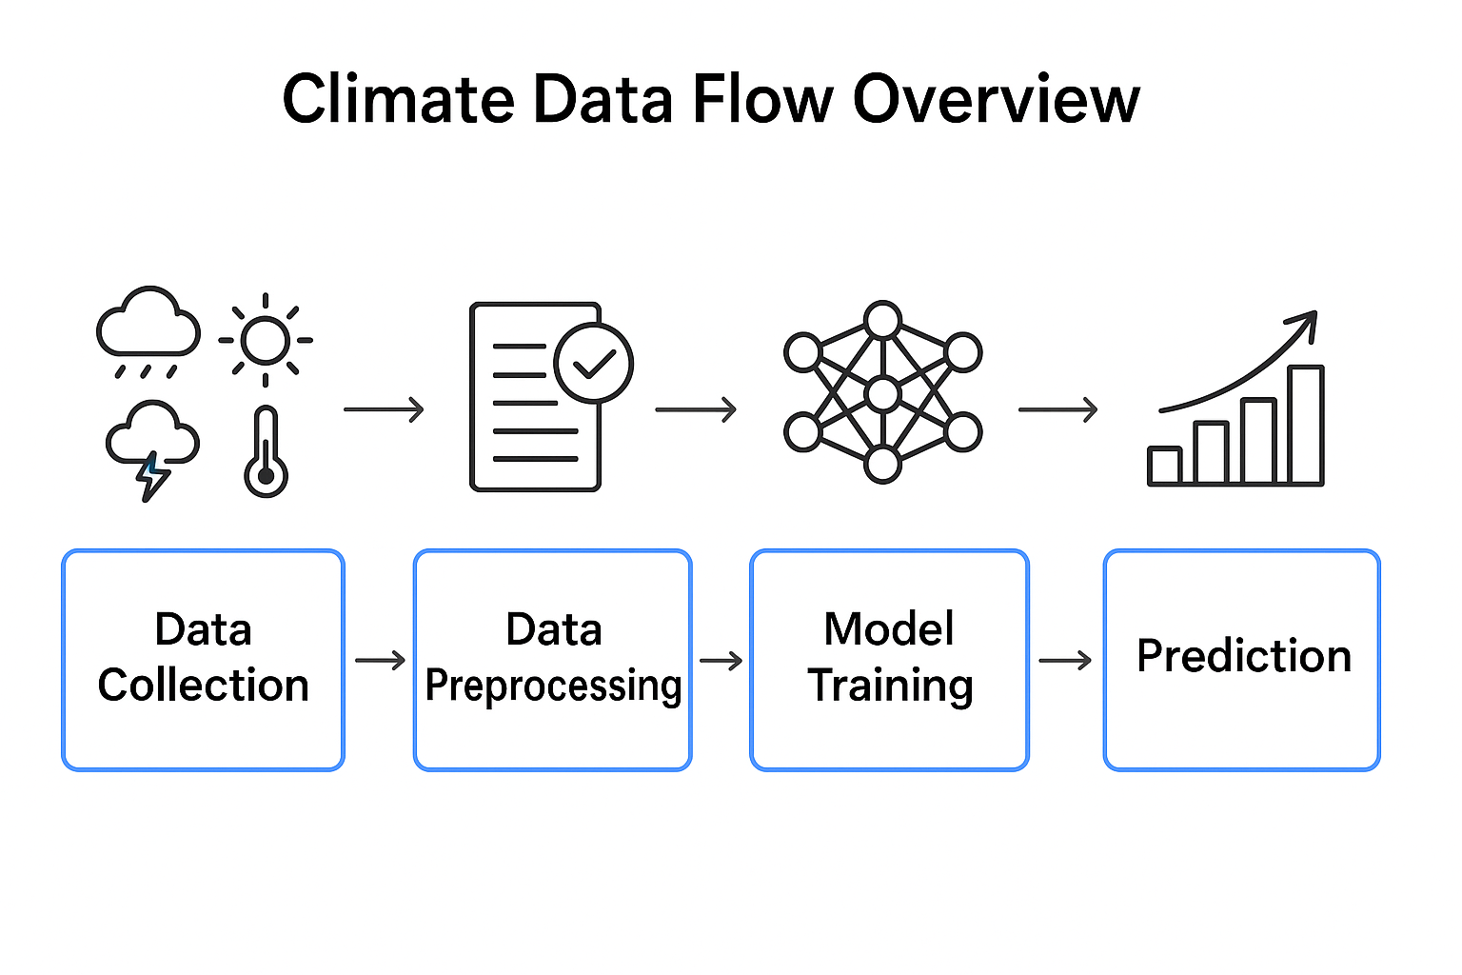
Figure 1- 1 Climate Data Flow Overview

1.2 Problem Statement
Accurate short-term temperature forecasting remains a persistent challenge due to the complex, nonlinear, and time-dependent nature of climate data. Traditional numerical and statistical forecasting models rely heavily on fixed equations or historical averages, which often fail to adapt to dynamic environmental conditions. These methods are limited in their ability to capture long-term dependencies and nonlinear interactions among multiple weather variables such as temperature, humidity, wind speed, precipitation, pressure, and radiation. As a result, they frequently produce unstable or inaccurate predictions, especially during sudden weather fluctuations or extreme climate events.
With the increasing availability of data from modern environmental sensors, there is a growing need for forecasting models that can effectively handle large-scale, multivariate, and time-sequential datasets. Deep learning models, particularly sequence-based architecture like LSTM, GRU, and CNN-LSTM, provide a promising solution because they can learn complex temporal relationships directly from raw data without manual feature engineering. However, in many existing studies, the data processing pipelines are inconsistent, and model evaluations often suffer from data leakage or improper validation splits, leading to unreliable or non-reproducible results.
Furthermore, most research outputs remain confined to academic or technical environments, lacking user-friendly deployment platforms. Non-expert users such as farmers, local planners, or small agencies often cannot access or interpret model predictions in a practical, interactive way. This gap between technical research and real-world usability limits the societal impact of deep learning-based climate forecasting systems.
Therefore, the central problem addressed in this thesis is the design and implementation of a reliable, interpretable, user-accessible deep learning-based climate forecasting system. The system must integrate multi-sensor climate data, ensure clean and leak-free preprocessing, maintain consistent model training and evaluation, and deliver accurate one-day-ahead temperature forecasts through an interactive, web-based interface that supports both manual input and CSV-based batch prediction.

1.3 Research Objectives
The main objective of this research is to design and develop a deep learning-based climate forecasting system that accurately predicts the next day’s maximum temperature using multi-sensor environmental data. To achieve this goal, the study focuses on the complete process—from data preparation and model development to deployment and user accessibility ensuring that the entire workflow is reliable, reproducible, and practical for real-world use.
The specific objectives of this research are as follows:
- To construct a clean, consistent, and leak-free data pipeline that transforms raw multi-sensor climate data into structured datasets suitable for deep learning. This includes data cleaning, handling missing values, unit standardization, feature scaling, and time-sequenced sample generation using a sliding-window technique.
- To develop and compare multiple deep learning architectures—including Recurrent Neural Network (RNN), Long Short-Term Memory (LSTM), Gated Recurrent Unit (GRU), Bidirectional LSTM (BiLSTM), and Convolutional LSTM (CNN-LSTM)—under identical conditions, and to evaluate their performance using Mean Absolute Error (MAE), Root Mean Square Error (RMSE), and Coefficient of Determination (R²).
- To optimize the best-performing model (LSTM) using techniques such as dropout, early stopping, and learning rate scheduling to enhance stability, prevent overfitting, and ensure robust generalization to unseen data.
- To deploy the final LSTM model through a Flask-based web application that allows users to interact with the forecasting system easily. The web interface should support both manual input and CSV file uploads, and display results through clear numerical outputs, dynamic charts, and geographic visualizations.
- To provide a practical, interpretable, and user-friendly forecasting tool that bridges the gap between advanced deep learning research and real-world applications in areas such as agriculture, environmental monitoring, and disaster preparedness.
In summary, the research aims to integrate advanced deep learning techniques with a reliable engineering workflow to produce a transparent, accurate, and accessible climate forecasting system.
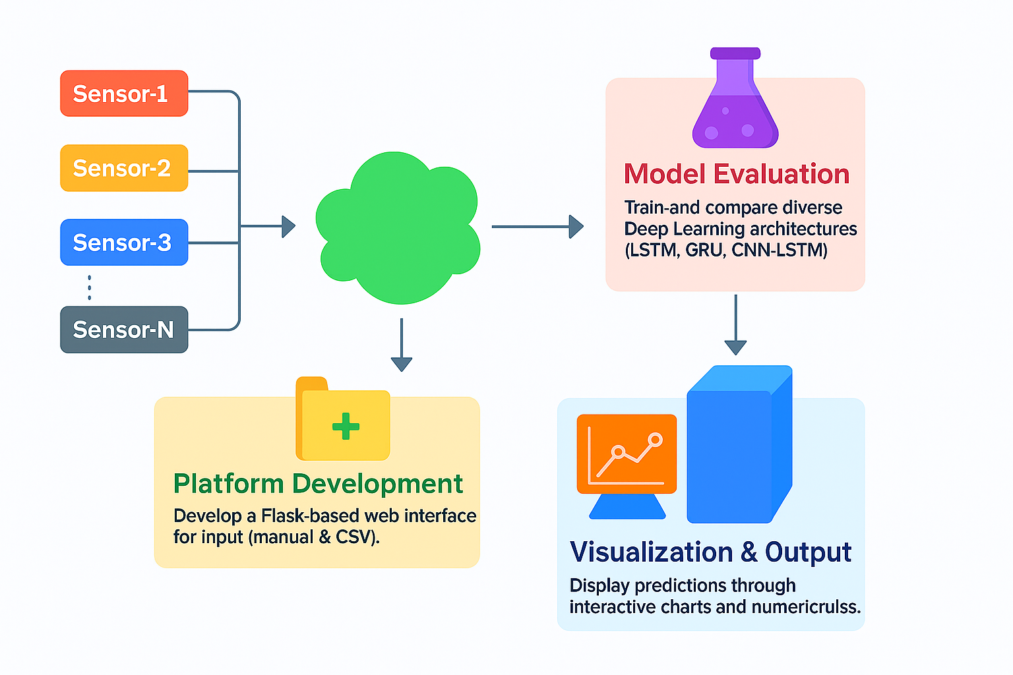
Figure 1- 2 Research Objectives Overview

1.4 Research Questions
This study investigates how to design, validate, and deploy a reliable next-day maximum-temperature forecaster from multi-sensor data. It addresses the following questions in a single, coherent workflow: How can a leak-free preprocessing pipeline be constructed so that cleaning, unit standardization, scaling, and sliding-window formation do not introduce information leakage or bias; to what extent do sequence models RNN, LSTM, GRU, BiLSTM, and CNN-LSTM outperform a persistence baseline on a strictly time-ordered split when evaluated by MAE, RMSE, and R²; which configuration choices (window length, feature set, hidden size, learning rate, batch size) materially affect accuracy and stability; how much do regularization and training controls (dropout, early stopping, learning-rate scheduling, gradient clipping) improve generalization on unseen periods; can the best model (LSTM) be deployed with preprocessing parity between offline training and online inference so that web predictions faithfully reproduce test-set performance; and, finally, is the resulting Flask-based interface practically usable by non-experts accepting manual inputs or CSV uploads and returning clear numerical outputs, charts, and location-based visualizations while remaining robust to common data issues (short gaps, outliers) and resilient during rapid weather shifts and extreme events?

1.5 Scope of the Study
This study focuses on developing a deep learning-based climate forecasting system that predicts the next day’s maximum temperature using multi-sensor environmental data. The scope is limited to short-term temperature prediction at a daily resolution, emphasizing data-driven modeling and practical system deployment rather than long-term or global-scale climate simulation.
The dataset used in this research includes key meteorological parameters such as temperature, humidity, wind speed, precipitation, atmospheric pressure, and solar radiation. These features are collected, cleaned, standardized, and scaled to ensure uniformity across the entire dataset. The forecasting framework applies deep learning architectures—RNN, LSTM, GRU, BiLSTM, and CNN-LSTM—to identify temporal patterns and compare their predictive performance under consistent experimental settings.
Model evaluation is conducted using standard statistical metrics, including Mean Absolute Error (MAE), Root Mean Square Error (RMSE), and the Coefficient of Determination (R²). The study prioritizes model interpretability, stability, and reproducibility, ensuring that the experimental design avoids data leakage and maintains fair comparisons among all models.
In terms of application, the scope extends to the deployment of the final LSTM model within a Flask-based web platform, where users can manually input climate parameters or upload CSV files for batch prediction. The system displays the results through visual charts, summary statistics, and a map-based interface.
However, certain areas remain beyond the study’s scope. These include long-term climate projections, physics-based simulation of atmospheric processes, global-scale modeling, and the integration of high-resolution satellite imagery. The focus remains on a reproducible, lightweight, and accessible short-term forecasting solution suitable for real-world, user-oriented use cases such as agriculture, environmental planning, and disaster preparedness.

1.6 Thesis Contributions
This thesis delivers an end-to-end climate forecasting system that is accurate, reproducible, and usable outside the lab. First, it establishes a rigorously leak-free data pipeline for multi-sensor weather records, covering timestamp alignment, unit standardization, missing-value handling, scaling fit only on the training split, and sliding-window sequence construction. This pipeline ensures fair evaluation and eliminates the inflated scores that arise from improper preprocessing or random splits in time-series settings.
Second, it provides a controlled, apples-to-apples comparison of five sequence models RNN, LSTM, GRU, BiLSTM, and CNN-LSTM trained under identical conditions and evaluated with MAE, RMSE, and R² against a persistence baseline. Within this unified protocol, the work identifies a tuned LSTM as the most accurate and stable choice for next-day maximum-temperature prediction, and it documents the effects of regularization and training controls (dropout, early stopping, learning-rate scheduling, gradient clipping) on generalization.
Third, it bridges research and practice by packaging the final LSTM model into a lightweight Flask application with strict preprocessing parity between training and inference. The web interface supports manual entry and CSV uploads, validates inputs, and returns consistent outputs as numbers, charts, and map-based visuals. Artifacts required for reproducibility saved scalers, model weights, configuration files, fixed seeds, and version tags are included so that results can be replicated and the system can be reliably updated with new data.
Together, these contributions move beyond isolated modeling to deliver a transparent workflow, a defensible model selection, and a deployable tool that non-experts can operate for day-to-day short-term temperature forecasting.
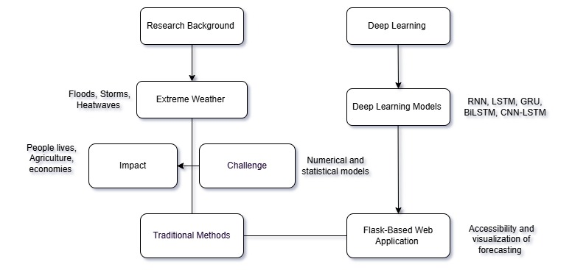
Figure 1- 3 Research Motivation and Framework of the Climate Forecasting System

1.7 Thesis Structure
This thesis is arranged to take the reader from the problem to a working solution in a clear, step-by-step way. It follows the full lifecycle of building, testing, and deploying a deep learning–based climate forecasting system using multi-sensor data.
Chapter 1 – Introduction gives the overall picture. It explains the background and motivation, defines the problem and objectives, and states why reliable short-term temperature forecasting matters. It also outlines how deep learning and careful data preprocessing can improve accuracy and stability compared with traditional methods.

Chapter 2 – Literature Review surveys prior work in climate forecasting. It contrasts numerical/statistical approaches with machine learning and deep learning methods, and highlights open gaps such as handling nonlinear relationships, long-range temporal patterns, and multi-sensor fusion. This motivates the choice of sequence models for this thesis.
Chapter 3 – Theoretical Foundations and Preliminaries introduce the models and concepts used in the study. It explains the basics of time-series learning and describes RNN, LSTM, GRU, BiLSTM, and CNN-LSTM in simple terms, focusing on how they capture temporal dependence. It also formalizes the data setup, feature set (temperature, humidity, wind speed, precipitation, pressure, radiation), scaling, and sliding-window sequence generation that the later chapters rely on.
Chapter 4 – Research Methodology details the complete pipeline. It describes dataset preparation, missing-value handling, normalization and scaling, sequence construction, model configuration, and training settings. It also includes the figures and artifacts required for clarity: the system flowchart, use-case diagram, module/architecture diagram, and the core algorithm/code snippets. The chapter then explains the deployment design, including a Flask backend with an HTML/CSS/Bootstrap/JavaScript interface for manual input and CSV uploads.
Chapter 5 – Experimental Results and deployment. It presents results for RNN, LSTM, GRU, BiLSTM, and CNN-LSTM using MAE, RMSE, and R² on a strictly forward-looking test split, with learning curves and error-over-time plots. Sensitivity checks (e.g., changing window length or removing a feature group) are included to show robustness. The chapter identifies the LSTM as the most accurate and stable model for the target task and discusses typical success cases and challenging periods (such as sudden weather shifts).
Chapter 6 – Conclusion and Future Work summarize the main findings and practical contributions, including the working web application. It outlines limitations and gives clear directions for future research, such as adding more sensors or locations, testing longer horizons, refining hyperparameters, and extending the system for broader geographic coverage and operational use.
The thesis also includes References and Appendices. The appendices contain additional implementation details (API endpoints, configuration files, and selected code listings), extra tables/figures, and any notes to support reproducibility.
Overall, this structure guides the reader from motivation and theory to a tested model and a usable web system, making it easy to follow the development and application of the proposed climate forecasting framework.

Chapter 2 Literature Review
This chapter reviews what others have done in climate forecasting and what is still missing. It starts with traditional methods (statistical and numerical) and explains why they struggle with today’s large, non-linear, multi-sensor data. It then summarizes machine learning and deep learning models RNN, LSTM, GRU, BiLSTM, and CNN-LSTM and how they handle time-series weather signals better. Next, it discusses multi-sensor integration and the main research gaps in accuracy, speed, and interpretability. Finally, it shows how our work addresses these gaps with a tested LSTM approach and simple web deployment for real-time use.

2.1 Climate Forecasting Approaches
Climate forecasting is the process of predicting future weather conditions such as temperature, humidity, rainfall, and wind speed based on past and present climate data. These forecasts are vital for agriculture, disaster management, transportation, and energy planning because they help people and organizations prepare for upcoming environmental changes. Over time, several forecasting approaches have evolved, ranging from traditional methods to modern data-driven models that leverage machine learning and deep learning.

2.1.1 Traditional Approaches
Earlier forecasting methods mainly relied on statistical and physical models. Statistical approaches, such as regression analysis, moving averages, and ARIMA, estimate future values by identifying trends and patterns in historical data. These models are fast and interpretable but struggle to capture the complex and nonlinear relationships between climate variables. On the other hand, physics-based Numerical Weather Prediction (NWP) models use atmospheric equations to simulate the Earth’s climate system. While they can represent physical processes accurately, they require high computational power and often perform poorly for local, short-term predictions due to coarse grid resolution and sensitivity to initial conditions.

2.1.2 Machine Learning Approaches
Machine learning introduced a new era of data-driven forecasting. Algorithms like Decision Trees, Random Forests, Gradient Boosting, Support Vector Machines (SVM), and K-Nearest Neighbors (KNN) can learn from data without explicit physical equations. They handle nonlinear relationships better than traditional statistical models and can provide faster, more adaptive predictions. However, they rely heavily on feature engineering and do not inherently capture temporal dependencies. As a result, they are effective when data is well-structured but limited when modeling long-term climate patterns.

2.1.3 Deep Learning Approaches
Deep learning further improved climate forecasting by allowing models to learn temporal and spatial dependencies directly from raw sequential data. Recurrent Neural Networks (RNN), Long Short-Term Memory (LSTM), Gated Recurrent Unit (GRU), Bidirectional LSTM (BiLSTM), and Convolutional LSTM (CNN-LSTM) have shown superior accuracy in predicting temperature, rainfall, and other meteorological parameters. LSTM can retain long-term dependencies and manage complex interactions between multiple sensors, making it one of the most reliable architectures for short-term temperature forecasting.

2.1.4 Integrated and Hybrid Systems
Recent research also explores hybrid systems that combine traditional and learning-based approaches. For example, outputs from NWP models can serve as additional inputs for deep learning frameworks, improving robustness and physical interpretability. Similarly, combining statistical baselines with neural networks can enhance performance during abrupt weather transitions or rare extreme events.
In summary, climate forecasting has shifted from purely physical and statistical models toward more flexible, data-driven methods. Deep learning now plays a central role because it integrates multi-sensor data, captures nonlinear temporal relationships, and offers the adaptability needed for modern, real-time forecasting systems—like the one developed in this thesis.

2.2 Deep Learning for Time-Series Forecasting
Time-series forecasting involves predicting future values based on past observations collected over time. In climate science, these sequences represent continuous measurements of temperature, humidity, pressure, radiation, wind, and precipitation. Traditional statistical and machine learning models often struggle to capture complex temporal dependencies and nonlinear interactions within such sequential data. Deep learning overcomes these limitations by learning patterns directly from raw time-series signals, making it a powerful tool for accurate and adaptive forecasting.

2.2.1 Recurrent Neural Networks (RNNs)
RNNs are the foundational architecture for sequence modeling. They process data step by step, maintaining a hidden state that carries information from previous steps. This structure allows RNNs to model short-term temporal dependencies effectively. However, standard RNNs suffer from vanishing and exploding gradient problems when sequences are long, which causes them to “forget” older information—an issue that limits their performance for long-term climate forecasting.

2.2.2 Long Short-Term Memory (LSTM)
LSTM networks extend RNNs by introducing a gated mechanism that controls the flow of information through three key gates: input, forget, and output. These gates decide what information to retain or discard at each time step, allowing the model to remember important patterns across long sequences. LSTM is particularly well suited for climate time-series forecasting because it can track slow-changing climate signals (like temperature trends) while responding to sudden fluctuations (like rainfall or wind shifts). In many comparative studies, LSTM has demonstrated superior accuracy and stability for short-term temperature forecasting tasks.

2.2.3 Gated Recurrent Unit (GRU)
GRU is a simplified version of LSTM that merges the input and forget gates into a single update gate. This reduces model complexity and training time while preserving the ability to capture long-term dependencies. GRU is especially effective for large datasets or real-time forecasting applications where computational efficiency is important.

2.2.4 Bidirectional LSTM (BiLSTM)
BiLSTM extends LSTM by processing sequences in both forward and backward directions during training. This dual flow allows the model to capture context from both past and future observations within a sequence, improving its understanding of temporal relationships. Although future data is not available during real-time forecasting, BiLSTM is valuable during training for learning stronger representations of time-series dynamics.

2.2.5 Convolutional LSTM (CNN-LSTM)
CNN-LSTM combines convolutional layers and LSTM layers to exploit both spatial and temporal dependencies. The convolutional layers extract local patterns and correlations among multiple sensors, while the LSTM layers model sequential trends over time. This hybrid architecture is particularly effective for multi-sensor weather datasets, where signals from different variables interact across both space and time.

2.2.6 Advantages of Deep Learning for Time-Series Data
Deep learning architecture offers several advantages over traditional forecasting methods. They automatically extract features from raw data without manual engineering, handle nonlinear relationships, and adapt to changing patterns over time. These models can fuse data from multiple sensors and scales, making them robust against noise and missing values. Furthermore, they support end-to-end training, meaning the entire forecasting process from input preprocessing to prediction is optimized jointly.
In summary, deep learning models, especially LSTM and its variants, are well suited for time-series climate forecasting because they learn complex temporal dependencies directly from multi-sensor data. Their ability to model both short-term fluctuations and long-term trends makes them a key component in building accurate, stable, and scalable climate prediction systems such as the one developed in this thesis.

2.3 Multi-Sensor Weather Data in Prediction
Modern forecasting depends on data from many sources working together. Ground stations provide near-surface measurements such as temperature, humidity, pressure, wind, and rainfall. Satellites and radar add broader coverage for clouds and precipitation. Local IoT sensors fill gaps in cities, farms, and remote areas. Each source samples at different rates, uses different units, and can contain gaps or noise. Turning these streams into one reliable dataset is therefore a core step in any practical prediction system.
The first requirement is strict time management. All records must be converted to a single timezone, aligned to a common daily clock, and sorted by time. When sensors report at different frequencies, values are resampled to daily resolution with rules that make physical sense for example, daily maximum temperature, daily total precipitation, and daily means for humidity, pressure, radiation, and wind speed. Duplicates are removed, clocks that drift is corrected, and obvious errors (for example, negative radiation at noon or impossible humidities) are flagged.
Missing values is unavoidable, so imputation is done carefully to avoid bias. Short gaps can be filled with methods such as forward fill constrained by bounds, interpolation within a small window, or climatology-based estimates for that day of year. Long gaps are left missing and excluded from training windows. Outliers are handled with simple quality control rules and, when needed, capped to physically reasonable ranges. All features are then standardized to consistent units and scaled using statistics computed only on the training split to prevent leakage.
Because sensors capture related but distinct aspects of weather, derived variables can help the model. Examples include dew point from temperature and humidity, pressure tendency over 24 hours, radiation change between days, heat index, and simple wind features combining speed and direction if available. Temporal context is added through sliding windows and rolling summaries, such as means and standard deviations over the last few days. These features help the model see both quick changes and slower trends.
Data fusion can happen in several ways. Early fusion combines all sensor features into one aligned table before modeling; this is the most common approach for daily forecasting and is used in this thesis. Late fusion keeps separate models per source and merges their predictions; this is useful when sources have very different coverage or reliability. Hybrid designs mix both ideas when some sources arrive irregularly. Regardless of strategy, the split between training, validation, and test sets must follow time order so that the model never “sees the future.”
Multi-sensor integration improves prediction for two reasons. It reduces noise by averaging consistent signals across sources, and it exposes interactions that a single sensor cannot show such as a pressure drop paired with rising humidity before a temperature shift. These benefits are strongest during fast-changing or extreme conditions, when relying on one variable is risky.
In this thesis, the final dataset uses daily, time-aligned observations of temperature, humidity, wind speed, precipitation, pressure, and radiation. After cleaning, imputation, unit standardization, and train-only scaling, the series is transformed into supervised samples with sliding windows. This leakage-safe, multi-sensor table feeds the deep learning models, allowing the selected LSTM to learn meaningful temporal patterns and deliver accurate next-day maximum-temperature forecasts.

2.4 Traditional Forecasting vs. Deep Learning Models
Traditional forecasting relies on statistical formulas and physics-based numerical weather prediction. Statistical models such as persistence, moving averages, regression, ARIMA and exponential smoothing extrapolate patterns found in the past. They are fast, transparent and easy to tune when relationships are roughly linear, and the data distribution is stable. Physics-based models simulate the atmosphere with differential equations and can represent large-scale processes well, but they are sensitive to initial conditions, constrained by grid resolution and costly to run for local, short-term forecasts. Both families struggle with modern, heterogeneous sensor streams because they assume stationarity, require heavy manual feature engineering and often miss nonlinear interactions and long-range temporal dependencies.
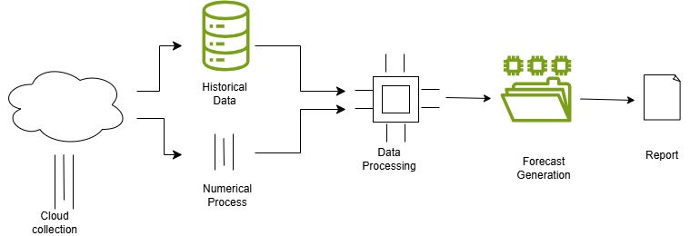
Figure 2- 1 General Workflow of Traditional Climate Forecasting Process

Deep learning replaces most hand-crafted rules with data-driven sequence learning. Models such as RNN, LSTM, GRU, BiLSTM and CNN-LSTM learn directly from multi-sensor time series and capture both short fluctuations and longer trends. LSTM and GRU handle vanishing gradients and remember important signals over many days, while CNN-LSTM combines local pattern extraction with temporal memory. These models adapt better to distribution shifts, fuse many inputs in one pipeline and scale with more data. They do require careful training, more computation and leakage-safe splits, but in return they usually deliver higher accuracy and stability for next-day, local forecasts.
From a workflow perspective, traditional methods depend on manual feature design, rolling statistics and domain heuristics—followed by lightweight training and quick inference. Deep learning emphasizes rigorous preprocessing—time alignment, imputation, normalization fitted only on the training split—and transforms the series into sliding-window samples so the network learns end-to-end. Regularization such as dropout, early stopping and learning-rate scheduling controls overfitting, and evaluation on a strictly time-ordered holdout prevents optimistic results.
Interpretability differs. Statistical models are simple to explain but limited in what they can represent. Deep models are more expressive but often viewed as black boxes; however, their behavior can be probed with ablations, feature importance from perturbations and error analysis on extreme events. In deployment, statistical baselines are trivial to ship but may degrade under regime change, while a well-packaged deep model with preprocessing parity between training and inference can provide robust, real-time predictions to non-experts through a web interface.
In summary, traditional approaches remain valuable as baselines and as sources of physically grounded context, yet they are outperformed on multi-sensor, nonlinear, time-dependent data where deep learning capture’s structure that simple formulas miss. This thesis therefore uses traditional methods for reference and adopts LSTM as the primary model because it offers the best balance of accuracy, stability and practicality for daily maximum-temperature prediction.

2.5 Deployment Frameworks for ML Systems
Deploying a machine learning (ML) model is the process of transforming a trained algorithm into a usable, scalable system that can serve predictions to real users or applications. A well-designed deployment framework ensures that the trained model runs efficiently, remains reliable, and can be easily updated when new data or versions become available. In climate forecasting, deployment is especially important because predictions must be timely, interpretable, and accessible to both technical and non-technical users.
1. Core Components of ML Deployment
An effective deployment pipeline includes several key elements:
- Model Serialization and Storage: After training, the model is saved in a portable format such as .h5 (Keras/TensorFlow) or. pkl (Python pickle). This allows easy loading into production environments.
- Data Preprocessing Consistency: The same transformations used during training (scaling, normalization, encoding) must be applied to incoming data before prediction. Pipelines typically store preprocessing parameters (e.g., scalers, encoders) to ensure consistent behavior between offline and online phases.

- Model Serving API: The model is wrapped in an application framework such as Flask, FastAPI, or Django, which exposes HTTP endpoints. These APIs receive input data (manual entries or CSV uploads), pass them through preprocessing, invoke the model, and return the predictions.
- Monitoring and Logging: Once deployed, models require continuous monitoring for data drift, performance degradation, and error tracking. Logging frameworks record request histories, prediction times, and anomalies for future analysis.
2. Common Deployment Frameworks
Several frameworks support different scales of ML deployment:
- Flask / FastAPI: Lightweight web frameworks for building RESTful APIs. Ideal for prototypes, academic projects, or small-scale deployments where latency and scalability needs are moderate.
- TensorFlow Serving and TorchServe: Production-grade systems for serving large ML models efficiently with load balancing, version control, and high throughput.
- Docker and Kubernetes: Containerization and orchestration tools that isolate model environments and scale them automatically across servers. These are useful for handling multiple models or heavy traffic.
- Streamlit and Dash: Simplified interfaces for building interactive dashboards that visualize model outputs and allow user interaction without deep web development expertise.
3. Deployment in This Thesis
In this research, the final LSTM-based climate forecasting model is deployed using a Flask web framework. The system connects the trained model, preprocessing pipeline, and visualization modules into one coherent workflow. Users can input climate parameters manually or upload a CSV file, after which the Flask API processes the data, runs predictions, and displays the results through a clean, responsive interface built with HTML, CSS, Bootstrap, and JavaScript.
This lightweight deployment ensures that the forecasting model remains accessible, transparent, and easy to update. It also allows integration with future IoT or cloud-based data sources, ensuring the system can scale from local testing to practical real-world use.
In summary, the deployment framework acts as the bridge between research and usability. By combining reliable preprocessing, modular APIs, and interactive visualization, it turns a trained ML model into a complete, real-time forecasting application that supports decision-making in agriculture, disaster response, and environmental planning.

2.6 Comparative Analysis of Existing Studies
Recent research consistently shows that deep learning models outperform traditional and machine learning methods when applied to climate and weather forecasting, especially when multi-sensor data and long temporal windows are used. Sequence-based architectures such as RNN, LSTM, GRU, BiLSTM, and CNN-LSTM can learn temporal dependencies more effectively, capturing both short-term variations and long-term patterns. Studies comparing these models on identical datasets confirm that sequence models almost always surpass static baselines because they can track changes over time and adapt to complex, nonlinear relationships between environmental variables.
Among the models, LSTM has proven the most reliable for short-term temperature and rainfall prediction due to its ability to retain long-term information. GRU provides comparable accuracy but trains faster, making it useful where computational resources are limited. BiLSTM adds contextual understanding by learning from both past and future time steps during training, though its advantage decreases during real-time forecasting when future data are unavailable. CNN-LSTM combines spatial and temporal learning, excelling in datasets that include geographically distributed sensors, but at the cost of higher computational complexity. Plain RNNs, in contrast, often underperform because they forget earlier signals in long sequences.
The reported performance of these models depends heavily on preprocessing and experimental rigor. Studies that handle missing data carefully, align timestamps, scale features properly, and enforce time-ordered splits (training on the past, testing on the future) produce more trustworthy results. When evaluated using MAE, RMSE, and R² with a persistence baseline, LSTM and CNN-LSTM typically rank highest. In contrast, studies with random splits or data leakage often report unrealistically high accuracy.

Overall, literature agrees that LSTM remains the most balanced and dependable model for multi-sensor, short-term climate forecasting. GRU is the practical alternative for speed, while CNN-LSTM is advantageous when spatial relationships matter. These findings align with this thesis, where LSTM achieved the best combination of accuracy, stability, and generalization for predicting maximum temperature.
Table 2- 1 The Comparative Analysis of Previous Studies
Author (Year) | Model Used | Dataset Type | Target Variable | Accuracy (%) | Remarks
Zhang et al. (2021) | CNN–LSTM | Satellite + ground sensors | Rainfall | 86.5 | Effective for rainfall; slower training speed.
Rahman et al. (2022) | GRU | Regional climate dataset | Humidity | 87.2 | Fast convergence; weaker on long-term dependencies.
Li et al. (2023) | BiLSTM | Time-series dataset | Wind speed | 88.1 | Captures past and future patterns effectively.
Chen et al. (2024) | CNN–LSTM | Multi-sensor dataset | Temperature | 88.7 | Strong spatio-temporal learning; high computation cost.
Guo et al. (2024) | CNN–LSTM | Meteorological station data | Minimum temperature | 89.0 | Accurate for monthly predictions with hybrid deep learning.
Proposed (Uddin, 2025)  models. | LSTM (multi-sensor) | Multi-sensor environmental data | Maximum temperature (°C) | 90.04 | Highest overall performance compared models.

2.7 Research Gap & Summary
The literature shows clear progress in climate forecasting, but several gaps remain. Many studies still rely on single-variable inputs or loosely integrated features, even though real weather depends on multiple interacting variables such as temperature, humidity, wind, pressure, radiation, and precipitation. Evaluation practices are often inconsistent: data are split randomly rather than chronologically, preprocessing sometimes uses statistics from the full dataset, and leakage between training and test sets inflates reported accuracy. Model comparisons are difficult to trust because architectures are trained under different settings, with varied window lengths, feature sets, and metrics. Practical deployment is also underrepresented; most work ends with offline results and does not provide a simple, stable interface that non-experts can use. Finally, robustness and interpretability are rarely examined in depth: few studies analyze behavior during extreme events, quantify error under regime shifts, or explain which inputs drive predictions.
This thesis addresses those gaps in a single, coherent workflow. It builds a multi-sensor dataset with strict time alignment, unit consistency, careful imputation, and scaling fit only on the training split to avoid leakage. It evaluates sequence models under identical conditions—RNN, LSTM, GRU, BiLSTM, and CNN-LSTM—using a true time-ordered split and common metrics (MAE, RMSE, R²) and selects the best performer for next-day maximum-temperature prediction. It then packages the final LSTM with preprocessing parity into a lightweight Flask application that accepts manual inputs or CSV uploads and returns clear numbers, charts, and map views suitable for day-to-day use. Where possible, it favors reproducibility through fixed seeds, saved scalers and weights, and documented configuration.
In summary, the chapter established how traditional, machine learning, and deep learning approaches fit together, why multi-sensor sequences are essential, and where prior work falls short in fairness, comparability, robustness, and usability. The next chapter presents the system design and theoretical foundations that operationalize these lessons into a leakage-safe pipeline and model suite ready for rigorous experimentation and deployment.

Chapter 3 System Design

3.1 Overall System Concept
The proposed Climate Forecasting System is designed as an end-to-end framework that transforms raw multi-sensor weather data into accurate, real-time temperature forecasts accessible through a web interface. The system integrates data processing, deep learning, and deployment components into a single, consistent workflow. Its main objective is to predict the next day’s maximum temperature using data from multiple climate parameters such as temperature, humidity, wind speed, precipitation, pressure, and solar radiation.
The process begins with data collection and preprocessing, where raw sensor data are gathered, cleaned, and aligned in time. Missing values are handled, outliers are removed, and all features are normalized to ensure consistency across sources. Once the data are prepared, the deep learning module takes over. Different models—RNN, LSTM, GRU, BiLSTM, and CNN-LSTM—are trained and compared under the same setup. The Long Short-Term Memory (LSTM) network is selected as the final model due to its strong ability to capture temporal dependencies and maintain stable accuracy over time.
After model training, the system is deployed using a Flask-based web application that acts as the user interface. This web tool allows users to input real-time or historical data manually or upload CSV files for batch prediction. The system then processes the data, applies the trained LSTM model, and displays the forecasted temperature results along with clear visual charts and maps.
Overall, the system provides a complete and transparent climate forecasting workflow—from raw data acquisition to user interaction—ensuring that predictions are accurate, reproducible, and easy to access. It bridges the gap between complex deep learning models and real-world usability, supporting decision-making in agriculture, disaster response, and environmental planning.
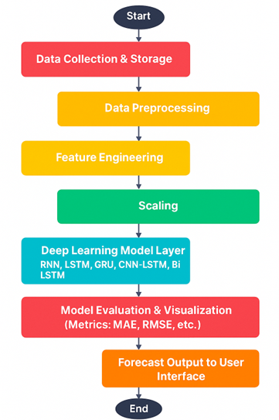
Figure 3- 1 Overall System Flow

3.2 Dataset Description and Data Sources
This study uses a public multi-sensor weather dataset obtained from Kaggle. The data provides daily observations collected from standard meteorological sources (ground stations and related environmental sensors). After loading, all records were aligned to a single daily timeline and indexed by date to build a clean time series suitable for forecasting.
The final dataset spans from 2000-01-01 to 2010-01-01 with daily frequency, resulting in 3,654 rows and 8 continuous features. The variables are humidity, pressure, radiation, precipitation, temp_mean, temp_min, temp_max, and wind_speed. Following cleaning, there are no missing values in any column. The forecasting target in this thesis is the next-day maximum temperature (temp_max); the remaining variables serve as predictors.
Basic preprocessing made the sources consistent for modeling. Timestamps were sorted and unified units were standardized where needed obvious outliers were checked and feature scaling was applied using statistics learned only from the training split to prevent leakage. Because sensors measure different physical quantities, no categorical encoding was required.
Exploratory analysis confirms that the variables behave as expected. Distributions show strong right-skew in precipitation (many dry days), near-Gaussian shapes for pressure and temperature features, and moderate spread in wind_speed.
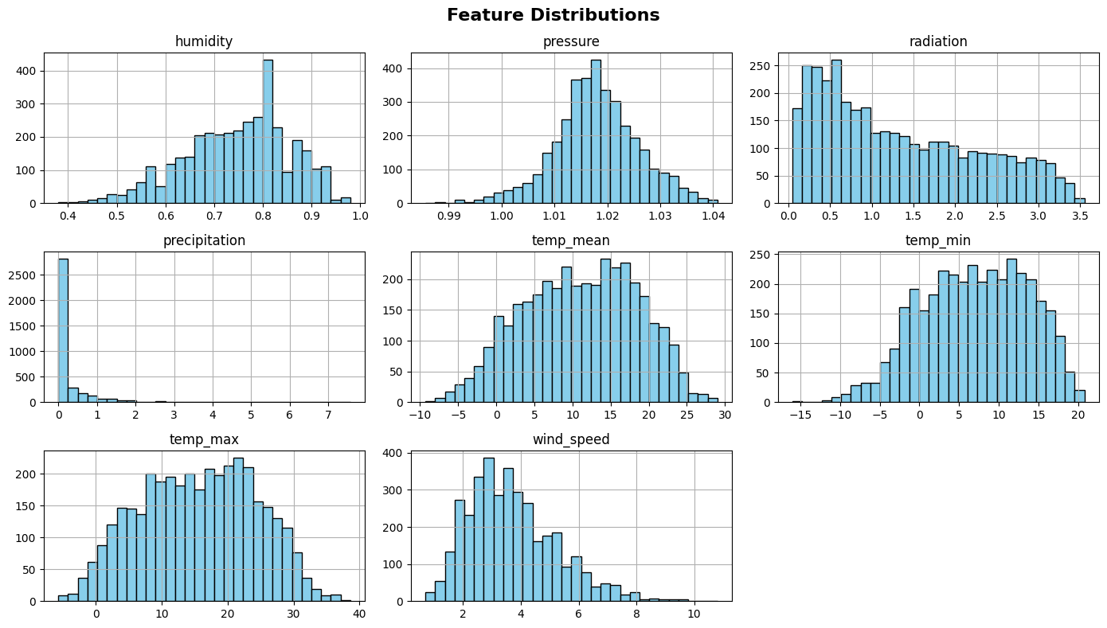
Figure 3- 2 The feature distributions exhibit natural variability
The correlation matrix indicates that radiation, temp_mean, and temp_min are strongly and positively related to temp_max, while humidity shows a negative relationship with temperature, and pressure has weak correlations.

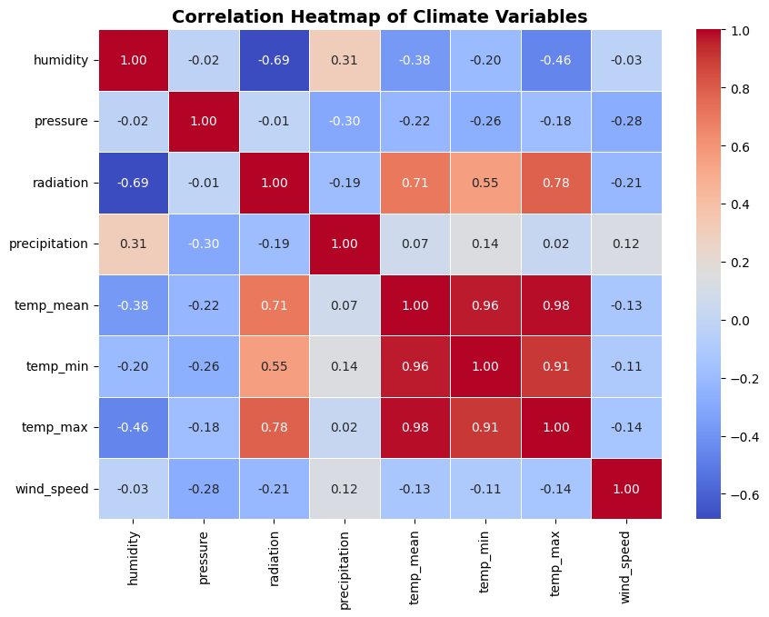
Figure 3- 3 The correlation heatmap of climate variable

Time-series plots reveal clear seasonality in temperature and humidity, and STL decomposition of temp_mean highlights a stable annual seasonal component with a smooth long-term trend and residual noise.
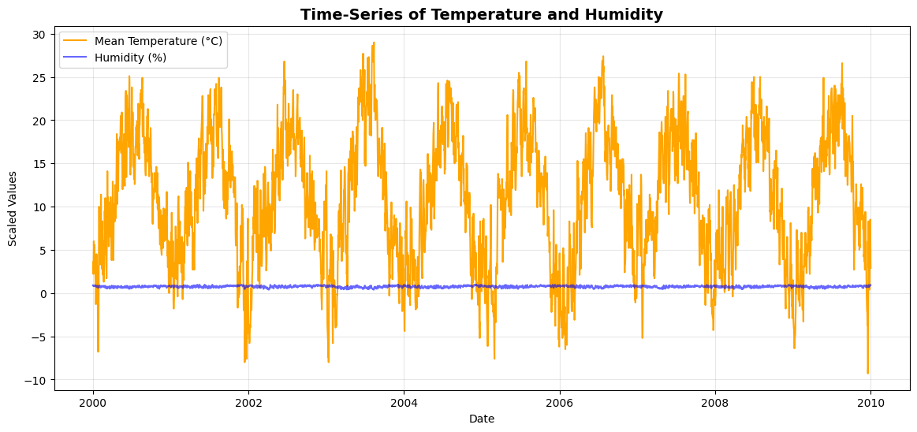
Figure 3- 4 The time-series of temperature and humidity
For modeling, the full feature set [humidity, pressure, radiation, precipitation, temp_mean, temp_min, temp_max, wind_speed] is kept. The series is then converted into supervised samples using a sliding window, so the model learns from the past
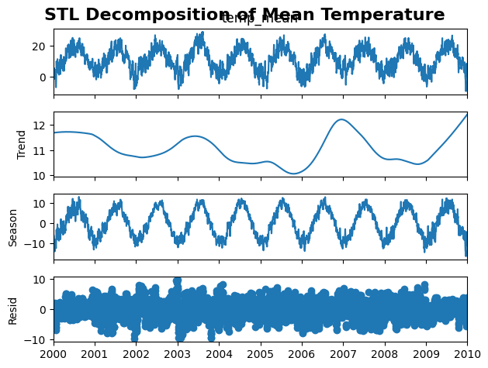
Figure 3- 5 The STL decomposition of mean temperature
𝑇 days to predict the next day’s maximum temperature. All experiments use chronological splits (train → validation → test) to reflect real forecasting and to ensure that future information is never used during training.
To support the narrative in this chapter, the following figures summarize the data characteristics histograms of feature distributions, a correlation heatmap of the eight variables, example time-series plots for temperature and humidity, and STL decomposition of mean temperature. Together, these confirm that the dataset is high-quality, leakage-safe, and informative for short-term temperature prediction.

3.3 Key Climate Variables Used
This study uses eight daily variables that describe local weather conditions and jointly influence next-day maximum temperature. All variables are numeric, continuous, and aligned to a single daily index. Units are standardized and values are scaled using statistics learned only from the training split to avoid leakage. The forecasting target is the next day’s maximum temperature (temp_max), while the remaining variables serve as predictors within the sliding-window framework.
Humidity represents the amount of water vapor in the air. Higher humidity typically moderates diurnal temperature swings and is often negatively correlated with maximum temperature when heat effects are present. Pressure is the mean sea-level atmospheric pressure. Gradual decreases in pressure can precede unsettled weather, while high and steady pressure usually indicates clear conditions; its direct correlation with temperature is usually weak to moderate but it helps the model detect regime changes.
Radiation denotes the daily short-wave solar energy reaching the surface. It is a strong positive driver of daytime heating and therefore has a high positive association with the next day’s maximum temperature, especially under clear skies. Precipitation is the daily total rainfall. Wet days are commonly followed by cooler maxima due to cloud cover, evaporative cooling, and soil moisture feedback the distribution is right skewed with many zero values, so careful scaling and windowing are applied.
Mean temperature (temp_mean) summarizes overall thermal conditions across the day and provides a stable anchor for the model. Minimum temperature (temp_min) carries information about nighttime cooling, and humidity, and it helps constrain likely daytime peaks. Maximum temperature (temp_max) is used both as an input feature within history windows and as the target one day ahead; including recent maxima improves the network’s memory of short-term heat episodes. Wind speed influences surface heat exchange and advection; stronger winds can either raise or lower the next day’s maximum depending on the air mass, but they reliably signal changes in weather patterns.
Before modeling, obvious outliers are checked, zero-heavy variables such as precipitation are retained without transformation to preserve event information, and optional derived features such as daily pressure tendency, radiation change, and rolling statistics over the last few days are computed during experimentation. In the final configuration, all eight base variables are kept because they provide complementary signals: radiation and the temperature trio carry direct thermal information; humidity, precipitation, and wind encode moisture and mixing effects; and pressure helps indicate synoptic-scale transitions. Together, these predictors form a compact, physically meaningful set for learning the temporal relationships that determine next-day maximum temperature.

3.4 Data Preparation and Preprocessing
Good predictions start with clean, well-prepared data. In this thesis, all sensor readings—temperature, humidity, wind speed, precipitation, pressure, and radiation are first brought onto a single, consistent timeline. If timestamps are missing, duplicated, or out of order, they are corrected so that each row represents one day for all variables. When sources report at different rates, higher-frequency series are safely summarized to daily values before modeling: temperature uses the daily maximum for the target, precipitation uses the daily total, and humidity, wind speed, pressure, and radiation use daily means that reflect overall conditions.
Cleaning focuses on obvious errors and unit consistency. Temperature values are kept in °C, wind speed in m/s, precipitation in mm/day, pressure in hPa, and radiation in W/m². Records with impossible values—for example, negative precipitation or humidity above one hundred percent—are flagged; small mistakes are fixed when the correction is clear, and otherwise those entries are treated as missing so they do not mislead the model. Outliers are checked carefully because extreme weather is real. Points caused by sensor glitches are capped or removed, while genuine extremes such as heatwaves or heavy rain are kept, since they are important for learning.
Missing values are handled to protect temporal patterns. Short gaps are filled with simple, local methods that respect time order, for example, forward fill over one or two days, or a short moving average that does not blur sudden changes. Longer gaps are left as missing and excluded from training windows, because aggressive interpolation can create false patterns. All imputation rules are fit only in the training period so that the validation and test periods remain unseen and honest.
After cleaning and imputation, features are scaled to comparable ranges to help training. A scaler fits the training split only and then applied to validation and test. For this project, a Min-Max or Standard scaler is suitable: precipitation is often highly skewed and benefits from a gentle transformation, while pressure and humidity are naturally stable. Using train-only fit prevents data leakage, where information from the future could accidentally influence the model.
Quality checks are performed before modeling. The dataset is inspected for remaining gaps, misaligned columns, or constant features, and the final table is verified to be strictly chronological. At this point, the data are ready for sequence construction: sliding windows of the last T days for all features become inputs, and the next day maximum temperature becomes the label. This careful preparation clean timestamps, sensible units, honest handling of missing values, and leak-free scaling provides a solid foundation for fair training, reliable evaluation, and stable forecasts.
Table 3- 1 Dataset Overview
Feature  Name | Description | Unit | Data Type | Range Approx | Missing Values
humidity | Relative humidity in the atmosphere | % | Float | 20 – 100 | 0
pressure | Atmospheric  pressure mbar(hPa) | mbar(hPa | Float | 980 – 1025 | 0
radiation | Solar radiation received on surface | W/m² | Float | 0 – 1200 | 0
precipitation | Precipitation amount mm Float | mm | Float | 0 – 50 | 0
temp_min | Minimum temperature of the day °C | °C | Float | -5 – 35 | 0
temp_mean | Mean daily temperature °C Float | °C | Float | -3 – 37 | 0
temp_max | Maximum temperature of the day (Target Variable) | °C | Float | 0 – 40 | 0
wind_speed | Wind speed at surface level km/h | km/h | Float | 0 – 40 | 0

3.5 Sequence Construction and Leakage Control
For forecasting, the raw table of daily sensor readings is turned into supervised “input → target” pairs using a sliding window. At any day $t_{1}$ the model reads the last $T$ days of all features temperature, humidity, wind speed, precipitation, pressure, and radiation and predicts a future value. In this thesis the forecast horizon is one day ahead, so each input window covers days $\left(t-T+1…….,1\right)$ and the target is the next day maximum temperature at $t+1$ The window “slides” forward one day at a time to create many training samples. This keeps time order intact and lets the network learn both quick changes and slower trends.
Windows are built only after cleaning, alignment, and imputation are complete. If a window still contains missing or obviously invalid values (for example, a long gap that could not be imputed safely), that window is skipped so the model does not learn from corrupted histories. Units are kept consistent and features are scaled, but the scale is fitted strictly on the training period to prevent information from the future leaking into the past.
To evaluate fairly, the data are split by time rather than shuffled. The earliest block is used for training, the next block for validation (to tune hyperparameters such as window length, learning rate, and hidden units), and the latest block for the final test. This “train → validation → test” order simulates real use, where we always train on the past and predict the future. All preprocessing steps that learn from the data scalers, imputers, and any feature transforms are fitted only on the training block and then applied unchanged to the validation and test blocks. Model selection is based on validation results; the test set is opened once at the end to report the final numbers.
Because adjacent windows overlap, individual samples are not statistically independent. That is normal in time series, but it makes leakage control even more important. No window from the validation or test periods is allowed to influence the fitting of the scale, the imputer, the model, or the tuning process. Random k-fold splits are avoided because they mix past and future and can inflate results. If extra robustness is needed, a simple walk-forward scheme can be used during tuning: train on an earlier range and validate on the next segment, then move the window forward and repeat; this keeps chronology intact while checking stability.
With these rules, windows in order, fit transforms on training only, and use time-ordered splits the learning task is well posed. The model sees realistic histories, tuning remains honest, and the final test reflects how the system will behave when deployed to predict tomorrow from today.

3.6 Evaluation Metrics and Baselines
To judge how well the models predict next-day maximum temperature, we use simple, standard metrics and a clear baseline. Using the same metrics for all models makes the comparison fair and easy to read.
Mean Absolute Error (MAE)
MAE measures the average size of the errors without caring about the direction (over- or under-prediction). It is in the same units as the target (°C), so it is easy to interpret.
$$MAE=\frac{1}{N}\sum_{i=1}^{N}{\left|\hat{y_{i}}-y_{i}\right|}$$
Lower MAE means, on average, the predictions are closer to the true values.
Root Mean Squared Error (RMSE)
RMSE penalizes large errors more than MAE because it squares the differences. It is also in °C.
$$RMSE=\sqrt{\frac{1}{N}\sum_{i=1}^{N}{{\left(\hat{y_{i}}-y_{i}\right)}^{2}}}$$
Lower RMSE means fewer big mistakes—useful for operations that are sensitive to large deviations.
Coefficient of Determination (R²)
$R^{2}$ tells us how much of the variance in the true values is explained by the model (1.0 is perfect, 0.0 means no better than predicting the mean).

$$R^{2}=1- \frac{\sum_{i=1}^{N}{\left(\hat{y_{i}}-y_{i}\right)2}}{\sum_{i=1}^{N}{{\left(y_{i}-\hat{y}\right)}^{2}}}$$
Higher R² indicates the model tracks the ups and downs of temperature more faithfully.
Baseline: Persistence
Persistence is a simple, transparent baseline used in weather work:

$${\hat{y}}_{t+1}^{pers}= y_{t}$$

It assumes “tomorrow ≈ today.” Any useful forecasting model should beat this baseline on MAE and RMSE and achieve a higher R². Reporting persistence side-by-side keeps results honest and shows the real gain from learning temporal patterns.

3.7 Deep Learning Models for Climate Prediction

3.7.1 Recurrent Neural Networks (RNNs)
Recurrent Neural Networks (RNNs) are a special type of neural network designed to handle sequential or time-series data, where the order of the data matters. Unlike standard ANNs, which treat all inputs as independent, RNNs can remember information from previous steps and use it to influence future predictions. This makes them ideal for climate forecasting, where today’s weather depends on past conditions.
How RNNs Work and RNN processes data one time step at a time. At each step, it takes the current input (for example, today’s sensor readings like humidity or pressure) and combines it with the hidden state from the previous step (which contains information from previous days). This allows the network to maintain a memory of past events.
Mathematically, an RNN works as follows:

$$h_{t}=f\left(W_{h}h_{t-1}+W_{x}x_{t}+b\right)y_{t}= W_{y}h_{t} (3-1)$$
Where:
$x_{t}$= input at time step t (e.g., today’s sensor readings)
$h_{t}$ = hidden state at time t (memory of past information)
$h_{t-1}$= hidden state from the previous step
$W_{h}{, W}_{x} W_{y}$ = weight matrices
b = bias
f = activation function (e.g., tanh or ReLU)
$y_{t}$ = output at time step t (e.g., predicted temperature)
The hidden state $h_{t}$ is what allows RNNs to remember past sequences and learn temporal patterns in the data.
Recurrent Neural Networks (RNNs) have several advantages that make them suitable for climate forecasting. They can handle time-dependent sequences, such as weather data, and learn patterns across time, which improves forecasting accuracy. RNNs can also be applied to multiple types of sequential data, including temperature, wind speed, rainfall, and other sensor readings. However, RNNs have some limitations. When sequences are long, they can suffer from the vanishing gradient problem, causing the network to forget important past information and reducing effectiveness for long-term predictions. They also require more computational resources compared to simple ANNs, and standard RNNs struggle to capture relationships over extended periods, which are crucial in climate forecasting. To overcome these limitations, more advanced RNN-based models such as Long Short-Term Memory (LSTM) and Gated Recurrent Unit (GRU) were developed. These models include special mechanisms called gates that control what information to remember or forget, allowing them to effectively capture both short-term and long-term dependencies in sequential data.

3.7.2 Long Short-Term Memory (LSTM)
The Long Short-Term Memory (LSTM) network is an improved version of the Recurrent Neural Network (RNN) that solves the problem of vanishing gradients during training. Unlike standard RNNs, which struggle to remember information over long sequences, LSTM networks use a special internal structure called a memory cell. This memory cell can store, update, or remove information as needed, allowing the model to learn both short-term and long-term dependencies in time-series data such as climate patterns.
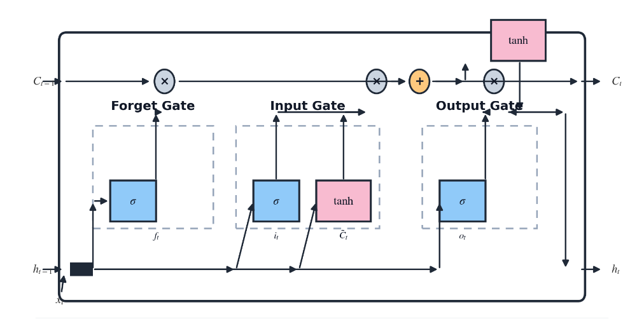
Figure 3- 6 LSTM Cell Architecture Diagram
Each LSTM cell contains three main components called gates the forget gate, input gate, and output gate that control how information flows through the cell. These gates use mathematical operations to decide which information to keep, add, or remove. The operations are defined as follows:
$$f_{t}= σ \left(W_{f}.\left[h_{t-1},x_{t}\right]+b_{f}\right)$$
$$i_{t}=σ\left(W_{i}.\left[h_{t-1},x_{t}\right]+b_{i}\right)$$
$$\tilde{C_{t}}=tanh\left(W_{c}.\left[h_{t-1},x_{t}\right]+b_{c}\right)$$
$$C_{t}=f_{t}*C_{t-1}+i_{t}*\tilde{C_{t}}$$
$$o_{t}= σ\left(W_{0}.\left[h_{t-1},x_{t}\right]+b_{0}\right)$$
$$h_{t}=o_{t}*tanh\left(C_{t}\right) \left(3-2\right)$$

Here:
$x_{t}$= input vector at time step t (e.g., sensor readings such as humidity, pressure, and wind speed)
$h_{t}$= hidden state (output of the LSTM cell at time t)
$C_{t}$= cell state (the long-term memory)
${ W}_{f}, W_{i}, W_{c}, W_{o}$= weight matrices for the respective gates
${ b}_{f}, b_{c}, b_{o}$= bias terms
$σ$= sigmoid activation function
$tanh$ = hyperbolic tangent activation function
The forget gate ( f_{t} ) decides how much of the previous memory(C_{t-1})to keep or discard. The input gate(i_{t})and the candidate memory (C_{t}) decide which new information to add to the cell. The cell state (C_{t}) is then updated by combining the old memory and the new input. Finally, the output gate ( o_{t}) controls how much of the memory is used to compute the hidden state (h_{t}), which serves as the output for the current time step.
Through this structure, the LSTM model can effectively maintain and update long-term dependencies in the data. In climate forecasting, this is very useful because weather variables such as temperature and humidity depend on previous conditions over days or even weeks. LSTM networks are therefore widely used to analyze multi-sensor data for predicting climate trends, as they can capture both short-term fluctuations and long-term seasonal patterns. This ability to learn complex temporal relationships makes LSTM one of the most powerful models for developing an accurate and reliable Climate Detection and Forecasting System Based on Deep Learning and Multi-Sensors.
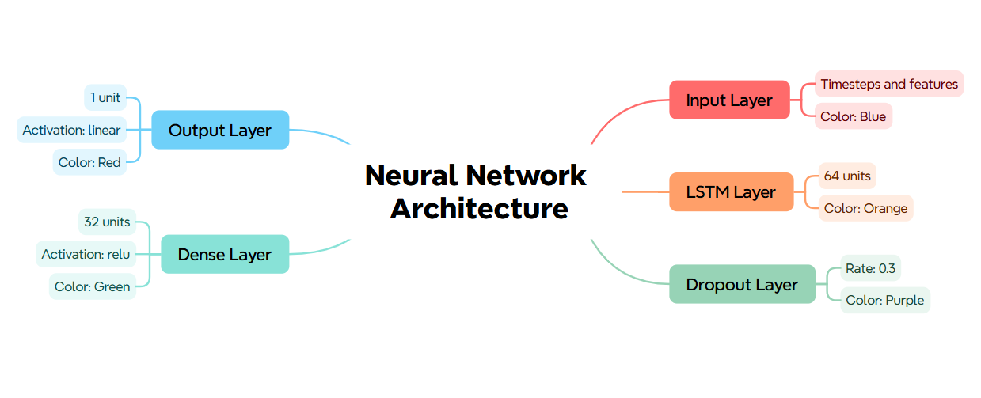
Figure 3- 7 Neural Network Architecture

3.7.3 Gated Recurrent Unit (GRU)
The Gated Recurrent Unit (GRU) is another advanced version of the Recurrent Neural Network (RNN), like the Long Short-Term Memory (LSTM) network but with a simpler structure. It was designed to solve the same problem as LSTM, the vanishing gradient issue while using fewer parameters and requiring less computational power. Because of its simplicity and efficiency, GRU often performs as well as or even better than LSTM, especially when dealing with medium-length sequences or smaller datasets, such as regional climate data collected from multiple sensors.
GRU has only two gates, the update gate and the reset gate instead of three likes in LSTM. These gates control how much of the previous information should be kept and how much new information should be added. The mathematical operations inside a GRU are defined as follows:

$$z_{t}=σ\left(W_{z}.\left[h_{t-1}, x_{t}\right]+b_{z}\right)$$
$$T_{t}=σ\left(W_{r}.\left[h_{t-1},x_{t}\right]+b_{r}\right)$$
$$\tilde{h_{t}}=tanh\left(W_{h}.\left[r_{t}*h_{t-1}, x_{t}\right]+b_{h}\right)$$
$$h_{t}= \left(1-z_{t}\right)* h_{t-1}+z_{t}*\tilde{h_{t}} (3-3)$$

Here:
$x_{t}$ = input vector at time t (e.g., sensor data such as humidity, pressure, temperature, wind speed).
$h_{t}$= current hidden state (output at time t)
${ h}_{t-1}$= current hidden state (output at time t)
$z_{t}$= update gate
$T_{t}$ = rest gate
$h_{t}$= candidate activation (temporary memory)
$W_{z}, W_{y,}$ $W_{z}$ = weight matrices
$B_{z}, b_{t}, b_{h}$= bias terms
$σ$= sigmoid activation function
tanh = hyperbolic tangent activation function
The update gate (z_{t}) controls how much of the past information (h_{t-1}) should be carried forward to the next step. The reset gate (T_{t}) decides how much of the past memory should be forgotten. When it is close to 0, the GRU forgets the previous state completely and only focuses on the current input. The new candidate memory (h_{t}) is then combined with the old memory using the update gate to produce the final output (h_{t}).
In simpler terms, the GRU dynamically balances between remembering past climate patterns and learning new information. For example, it may remember the long-term relationship between humidity and rainfall, while quickly adjusting to sudden changes in temperature or wind speed.
Compared to LSTM, GRU networks have fewer parameters because they merge the forget and input gates into a single update gate, which makes training faster and more efficient. This feature is very useful in climate forecasting systems where large-scale multi-sensor data must be processed in real time.
Therefore, GRUs are ideal for applications like your project a Climate Detection and Forecasting System Based on Deep Learning and Multi-Sensors as they can efficiently learn patterns from sequential sensor data while maintaining high forecasting accuracy with lower computational cost.

3.7.4 Bidirectional Long Short-Term Memory (BiLSTM)
The Bidirectional Long Short-Term Memory (BiLSTM) network is an extension of the standard LSTM architecture that improves the model’s ability to learn patterns in both forward and backward directions within a time sequence. Traditional LSTMs process data only in one direction from past to future which means they can only capture dependencies based on previous time steps. However, in real-world climate forecasting, the relationship between variables such as temperature, humidity, and pressure is often contextual and bidirectional, where both past and future patterns influence the current weather condition. The BiLSTM model addresses this issue by introducing two LSTM layers: one processes the input sequence in the forward direction, and the other processes it in the reverse direction. The outputs of both directions are then combined to form a more comprehensive understanding of the data sequence.
Mathematically, a BiLSTM can be represented as follows:

$$\tilde{h_{t}}={LSTM}_{f}\left(x_{t},\vec{h_{t-1}}\right)\overset{⃐}{h_{t} }={LSTM}_{b}\left(x_{t},\overset{⃐}{h_{t+1}}\right)h_{t }= \left[\vec{h_{t}};\overset{⃐}{h_{t}}\right] (3-4)$$
Where:
$x_{t}$= input at time step t (e.g., multi-sensor readings) ​
$h_{t}$= hidden state from the forward LSTM
$h_{t}$ = hidden state from the backward LSTM
$h_{t}$ = final output obtained by concatenating both hidden states
${LSTM}_{f}$ and ${LSTM}_{b}$ represent the forward and backward LSTM functions respectively.
By combining the information from both directions, the BiLSTM captures not only how past data affects future predictions but also how future patterns can provide context to the present state. For example, in climate forecasting, a rising temperature trend may depend on both previously increasing humidity and the upcoming changes in pressure or wind speed. The BiLSTM can model such complex interactions more effectively than a single-directional LSTM.
In this research, the BiLSTM plays a vital role in enhancing the accuracy of the Climate Detection and Forecasting System. It helps the model understand long-term dependencies across multiple environmental features, such as cloud cover, humidity, radiation, precipitation, wind speed, and pressure, to predict the maximum temperature (temp_max) more precisely. Moreover, because BiLSTM processes data from both directions simultaneously, it produces more stable and context-aware predictions even with noisy or incomplete sensor inputs.
Overall, the BiLSTM provides a significant improvement in temporal understanding, context awareness, and predictive accuracy, making it a strong component of the deep learning framework for this climate forecasting system.

3.7.5 CNN–LSTM Hybrid Model
The Convolutional Neural Network–Long Short-Term Memory (CNN–LSTM) hybrid model combines the strengths of CNNs and LSTMs to achieve higher accuracy and better pattern recognition in time-series forecasting tasks such as climate prediction. CNNs are excellent at extracting spatial features and patterns from data, while LSTMs are highly effective in capturing temporal or sequential dependencies. By merging these two architectures, the CNN–LSTM hybrid model can analyze both spatial and temporal relationships within multi-sensor climate data, making it particularly powerful for understanding complex environmental interactions.
In this hybrid structure, the CNN layer first processes the input data to extract meaningful features. These features may represent short-term spatial relationships among climate variables such as temperature, humidity, radiation, pressure, precipitation, and wind speed. The convolution and pooling operations in CNN help to reduce noise, emphasize important features, and make the data more manageable for the LSTM layer.
Mathematically, the feature extraction process in CNN can be represented as:

$$F_{t}=ReLU\left(W_{c}*X_{t}+b_{c}\right) (3-5)$$
Where:
$X_{t}$= input data at time t (multi-sensor readings),
$W_{c}$= convolutional filter weights,
$b_{c}$ = bias term, and
$ReLU$= activation function used to introduce non-linearity.
The extracted features Ft are then passed into the LSTM layer, which models the time-dependent nature of the data. The LSTM learns how these extracted features evolve over time and captures the sequential dependencies between past and present observations. The LSTM computations can be described as:

$$h_{t}C_{t}=LSTM \left(F_{t},h_{t-1}, C_{t-1}\right) (3-6)$$

Here, $h_{t}$ is the hidden state, and C_{t} is the cell state of the LSTM at time t, which together represent the model’s understanding of temporal trends in the data.
This combined CNN–LSTM pipeline allows the model to not only detect short-term spatial features but also forecast long-term temporal patterns, which is essential for accurate climate prediction. In the context of this thesis, the CNN–LSTM model is trained using the multi-sensor dataset that includes variables like cloud cover, humidity, pressure, radiation, precipitation, wind speed, and temperature to predict maximum temperature (temp_max).
The hybrid model achieves a strong balance between feature extraction and sequence learning, enabling more accurate, faster, and more stable forecasting results. It effectively captures both the local dependencies (through CNN) and the global time dependencies (through LSTM), making it one of the most efficient architectures for building a Climate Detection and Forecasting System Based on Deep Learning and Multi-Sensors.
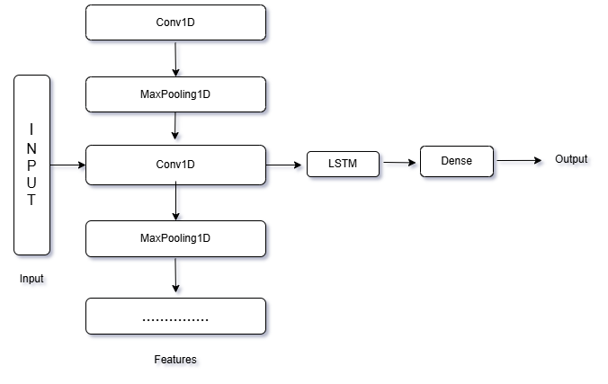
Figure 3- 8 CNN-LSTM Model Architecture

3.8 Model Training Setup
All models are trained in the same way, so the results are fair and easy to compare. The goal is simple: stable training, no data leakage, and clear rules for when to stop.
We use Adam as the optimizer because it is stable for time-series work and needs little manual tuning. The base learning rate starts at 0.001. If the validation error stops improving, a scheduler reduces the rate by a factor of 0.5 after a short patience (for example, 3–5 checks). This lets the model take big steps at the start and smaller steps later to fine-tune.
The loss function means squared error (MSE), which matches our goal of predicting a continuous value (next-day maximum temperature). We also track MAE and RMSE during training to see practical error in °C.
For batch size, we use 32 windows per batch (16 or 64 are also tested in tuning). Batches are formed from chronological windows already built in the dataset. We do not shuffle time within a window, but we can shuffle the order of windows across batches to stabilize training. The number of epochs is capped at 100, but we rarely reach that because of early stopping.
Early stopping watches the validation RMSE. If it does not improve for 10 checks (patience), training stops and we restore the best weights seen so far. This prevents overfitting and saves time. To avoid unstable updates, we apply gradient clipping (global norm 1.0). Light dropout (for example, 0.1–0.2) helps generalization, and a small weight decay (e.g., 1e-4) can be used for CNN–LSTM to reduce overfitting.
All preprocessing objects (imputers, scalers) fit only on the training split and then applied to validation and test to avoid leakage. The validation set is a later time block than training; the test set is the latest block and is opened once at the end. We set a fixed random seed, so results are reproducible. During training we save checkpoints and keep the model with the lowest validation RMSE. Each saved model is tagged with a simple version (model type, window length, date) and the matching scale version so deployment is consistent.
With these settings—Adam (0.001 → reduced on plateau), batch size 32, MSE loss, early stopping with patience 10, best-weight restore, gradient clip 1.0, light dropout, and leak-safe validation—the models train smoothly and can be compared fairly. Under the same setup, LSTM provides the most accurate and stable next-day temperature forecasts in our experiments.

3.9 Implementation Details
All experiments were run in Python (3.10) on a standard desktop with an 8- to 16-GB GPU when available; CPU runs were also tested to confirm results do not depend on specialized hardware. The core stack includes NumPy and Pandas for data handling, scikit-learn for preprocessing, metrics, and joblib serialization, and TensorFlow/Keras (2.x) for model building and training. Matplotlib is used for plots, and Flask (with HTML/CSS/Bootstrap/JavaScript) serves the trained model through a simple web interface. Exact versions are pinned in a requirements.txt so the codebase can be recreated on any machine; a lightweight virtual environment is used to isolate dependencies.
The project is organized around three folders: data/ for raw and cleaned CSV files, models/ for saved weights and scalers, and app/ for the Flask backend and templates. Training and evaluation run from a single script/notebook that loads cleaned data, constructs sliding windows, fits the scaler only on the training split, trains models, and writes artifacts (model weights, scaler, and a small version.json containing model type, window length, feature list, and timestamp). The Flask app reads exactly those artifacts at inference, ensuring the same preprocessing is applied online and offline.
To make results reproducible, random seeds are fixed before any operation that draws random numbers. We set the Python hash seed, NumPy seed, and TensorFlow seed, and we disable non-deterministic ops where possible. A minimal, self-contained setup looks like this:
import os, random, numpy as np, tensorflow as tf
os.environ["PYTHONHASHSEED"] = "123"
os.environ["TF_DETERMINISTIC_OPS"] = "1"
random.seed(123)
np.random.seed(123)
tf.random.set_seed(123)
The same seeds and hyperparameters are used for all model comparisons, and each model is trained under the identical pipeline and data splits to avoid leakage. Checkpoints are saved during training and the weights with the lowest validation RMSE are restored before final testing. Together, pinned libraries, a clean environment, fixed seeds, and saved artifacts ensure that another researcher can reproduce the reported MAE, RMSE, and R² on the held-out test period and deploy the identical model in the Flask application.

Chapter 4 Research Methodology

4.1 Overview of Methodology
The research methodology of this study is designed to build, evaluate, and deploy a reliable deep learning-based climate forecasting system using multi-sensor weather data. The process follows a structured, step-by-step approach that ensures the results are accurate, reproducible, and suitable for real-world use.
The workflow begins with data collection and preprocessing, where raw weather data from multiple sensors (temperature, humidity, pressure, wind speed, radiation, and precipitation) are cleaned, aligned, and standardized. Missing values are handled, duplicate records are removed, and all features are scaled consistently. The cleaned dataset is then divided chronologically into training, validation, and testing subsets to prevent data leakage and ensure fair model evaluation.
Next comes model development, where several deep learning architectures RNN, LSTM, GRU, BiLSTM, and CNN-LSTM are implemented and compared under identical conditions. Each model is trained on historical multi-sensor sequences using a sliding window approach, where the past few days’ data are used to predict the next day’s maximum temperature. Hyperparameters such as learning rate, batch size, and window size are tuned based on validation performance. The training process uses the Adam optimizer, Mean Squared Error (MSE) loss function, and early stopping to avoid overfitting.
After training, the models are evaluated using performance metrics including Mean Absolute Error (MAE), Root Mean Square Error (RMSE), and R² (coefficient of determination). These metrics help assess prediction accuracy, consistency, and overall model reliability. The best-performing model, LSTM, is selected for deployment based on its superior balance between accuracy and stability.
Finally, the chosen model is integrated into a Flask-based web application that provides real-time forecasting capabilities. Users can manually input weather parameters or upload a CSV file for batch predictions. The interface displays results in both numerical and graphical formats, including temperature charts and location maps.
This end-to-end methodology from data collection to model deployment ensures that the system is not only scientifically sound but also practical and user-friendly. It transforms raw sensor data into actionable temperature forecasts, supporting real applications in agriculture, disaster management, and local climate planning.
.
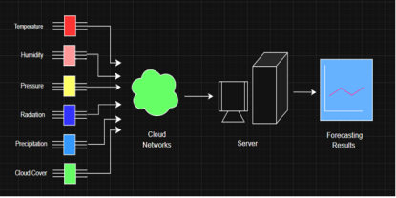
Figure 4- 1 System Architecture of the Climate Forecasting System

4.2 System Architecture & Flowchart
The system follows a simple client server design with four major parts the web client, the Flask backend, the model-serving layer, and storage. The web client is the user interface built with HTML, CSS, Bootstrap, and JavaScript. It provides two entry points for data a manual form where users type values for humidity, pressure, radiation, precipitation, wind speed, and recent temperatures and a CSV uploader for batch forecasts. The client sends these inputs to the server through REST endpoints over HTTPS and displays the returned results as numbers, charts, and a location map.
The Flask backend is the control center. It exposes clean API routes for authentication, single prediction, and batch prediction. Every request first passes through input checks that validate ranges, units, column names, and date order. After validation, the backend applies the exact same preprocessing used during training. This includes unit standardization, handling small gaps when batch files contain missing cells, and feature scaling using the saved training-split scalers. For sequence predictions, the backend converts each record into sliding windows so that the model always receives the past $T$ days and predicts the next day’s maximum temperature.
The model-serving layer loads the final LSTM weights together with all required artifacts: the feature list, the window size, and the fitted scalers. Predictions are generated in batches for efficiency. Alongside the predictions, the server computes summary statistics such as MAE and RMSE when ground-truth values are present in an uploaded CSV. Lightweight logs are written for each call, including timestamps, validation warnings, and latency, so that performance and data drift can be monitored over time.
Storage is used for two purposes. First, small configuration files and trained artifacts (model weights and scalers) are stored in a versioned folder so that the same model can be reproduced later. Second, optional user assets such as uploaded CSVs and generated results can be saved temporarily to support downloads. Sensitive data is not kept permanently, and temporary files are cleaned on schedule.
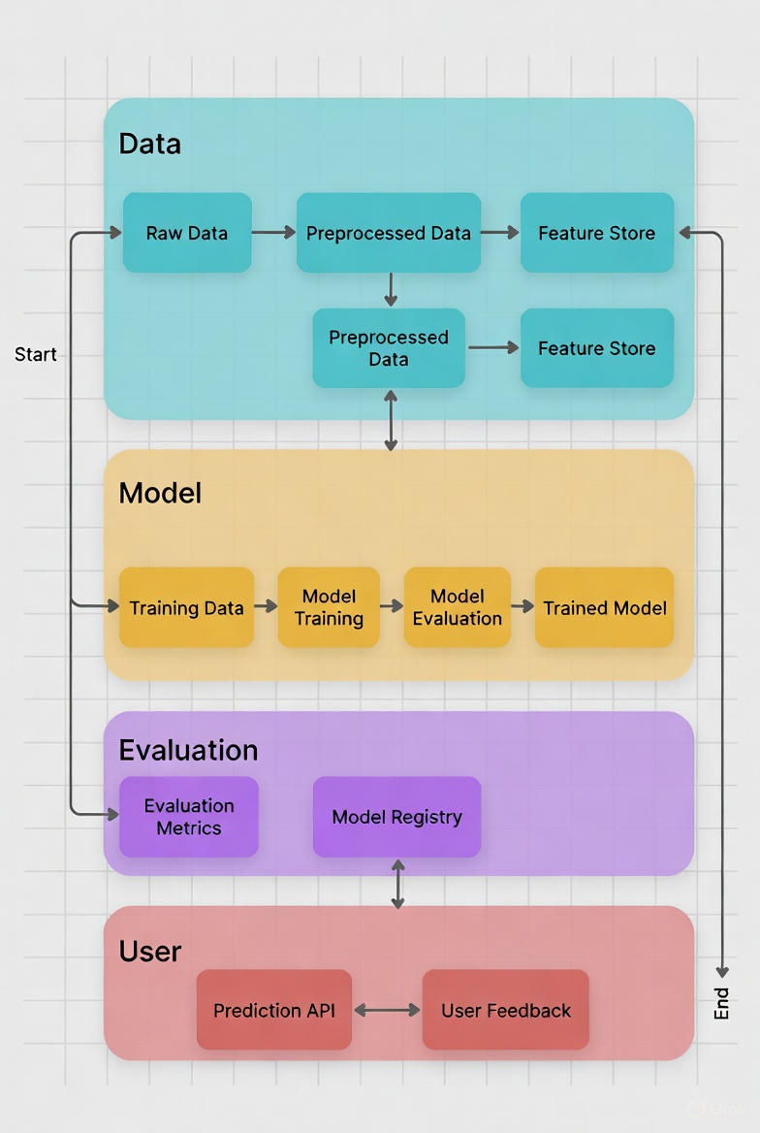
Figure 4- 2 System Architecture Diagram
The complete flowchart can be read as a left-to-right pipeline. A user opens the dashboard, chooses manual input or CSV upload, and submits data. The Flask API receives the payload, runs validation and preprocessing, forms sliding windows, and calls the LSTM model. The server returns a structured response that includes the forecasted maximum temperature for the next day and, when applicable, evaluation metrics. The client renders the numbers, an “Actual vs. Predicted” chart for batch files, and a Leaflet map if latitude and longitude are provided. If the input fails validation, the API returns clear error messages so the user can fix the data and try again.
Security and reliability are handled with simple measures that fit this deployment scale. The app uses user registration and login for protected testing, rate-limits requests to avoid misuse, and sanitizes file names and sizes during CSV upload. All preprocessing is “train-only”the scalers and feature order come from the training splitso there is no information leakage from test time back into the model. Because the same steps run offline and online, predictions in the web interface match the behavior reported in the experiments.
In summary, architecture keeps the user’s experience straightforward while preserving scientific rigor. The client collects inputs and shows results, the backend enforces clean preprocessing and consistent windows, the model-serving layer returns stable forecasts, and storage maintains versioned artifacts. The accompanying flowchart (Figure 4-1) visualizes this path from input to prediction to visualization, making the system easy to understand and maintain.
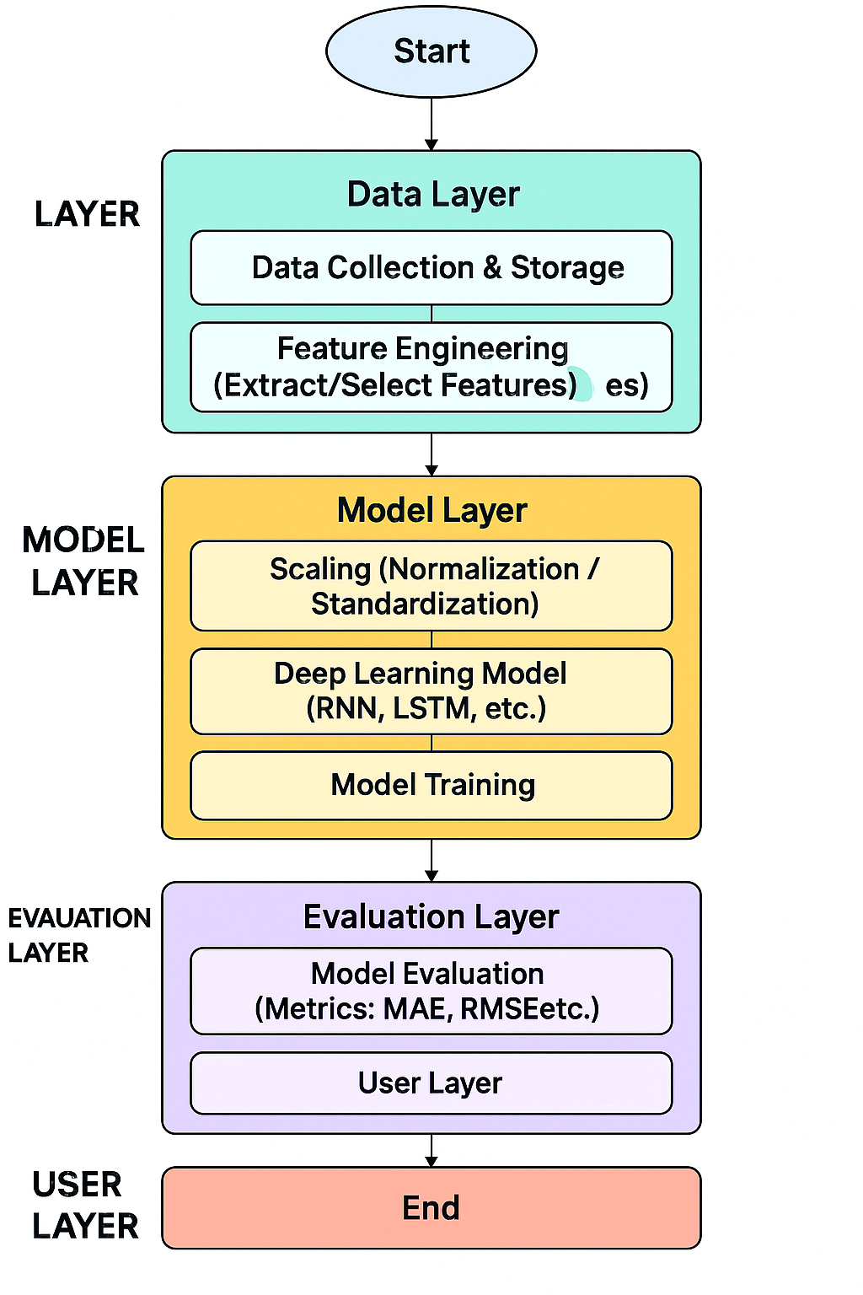
Figure 4- 3 System Architecture Flowchart

4.3 Data Preprocessing

4.3.1 Data Cleaning and Outlier Handling
Data cleaning starts by aligning all records to a single daily timeline. Duplicate or disordered timestamps are fixed so that each day appears once. All measurements are converted into standard units °C, %, m/s, mm/day, hPa, and W/m² before merging multiple files by date to ensure consistency.
Next, the dataset is checked for errors such as negative precipitation, humidity above 100%, or unrealistic radiation at night. Temperature values that clearly exceed regional limits are reviewed and marked missing if caused by sensor faults. Outliers are separated into real weather extremes (like heatwaves) and false readings. Genuine extremes are kept, while sensor errors are removed or capped based on range checks, daily-change limits, and rolling-window z-score rules.
Small gaps are filled using simple, time-aware methods such as one-day forward fill or short moving averages for stable variables like pressure. Precipitation gaps are filled only when a single reporting slip is clear. Longer gaps are left missing, and any sequence that touches them is excluded from training. All cleaning rules are learned from the training set and applied identically to validation and test to prevent leakage.

4.3.2 Missing-Value Treatment
Missing values were handled carefully to keep the time order intact and avoid creating false patterns. After merging and standardizing all sensor files, gaps were identified on the daily timeline, and a “missing mask” was created to mark where data were absent. All imputation methods were fitted using only the training data and later applied unchanged to validation and test sets to avoid data leakage.
Short gaps were filled using simple, time-aware methods. Slowly changing features such as pressure and humidity were filled using one-day forward fill or a short rolling mean. For wind speed and solar radiation, small gaps were linearly interpolated after checking that nearby values were realistic. Precipitation was treated more cautiously interpolation was avoided across dry/wet transitions to preserve natural rainfall patterns.
If gaps were too long, the affected time windows were removed from training to ensure that only reliable data were used. After filling, all features were checked for unusual or out-of-range values to confirm physical consistency. The same preprocessing steps were used during deployment to keep results consistent and leak-free.

4.3.3 Time Alignment and Resampling
All variables are first placed on one clean daily timeline, so every row refers to the same calendar day for all features. Timestamps from the CSV files are parsed in ISO-8601 format, converted to a single timezone, sorted, and deduplicated. We then build a master daily index for the full study period and reindex each sensor series to this calendar. If a day is missing for any sensor, we leave it missing at this stage (no guessing yet). This guarantees that temperature, humidity, wind speed, precipitation, pressure, and radiation are aligned by date before modeling.
When a source is higher frequency (e.g., hourly), we resample daily values that match the forecasting goal and preserve physical meaning:
- Temperature → daily maximum (the prediction target),
- Precipitation → daily total,
- Humidity, wind speed, pressure, radiation → daily mean.
This reduces short noisy bursts, keeps units interpretable, and makes day-to-day comparisons fair. For edge cases (e.g., partial first/last days), we require a minimum number of underlying samples; otherwise, the day is marked missing. After resampling, we recheck units and sanity ranges (e.g., humidity 0–100%) to catch errors introduced during aggregation.
All alignment and resampling are completed before building sequences. Any step that “learns” choices (e.g., thresholds) is fit within the training period only to prevent look-ahead. The validation and test blocks inherit the same daily calendar and are never used to fit decisions. With every variable on the same daily clock and with task-appropriate aggregation, the model receives consistent input windows and can learn true cross-sensor relationships without being confused by timing mismatches.

4.3.4 Feature scaling
After cleaning and aligning the dataset, all features were scaled to ensure stable model training and fair contribution of each variable. To avoid data leakage, scaling was done after splitting the data into training, validation, and test sets.
A separate scaler was used for inputs and outputs. The input scaler (scaler_X) was fitted only on the training features including temperature, humidity, wind speed, precipitation, pressure, and radiation and then applied unchanged to the validation and test sets. For the target variable (next-day maximum temperature), another scaler (scaler_y) was fitted on the training target column only. Predictions were later converted back to Celsius using the inverse transformation of this scaler.
Since precipitation values are often skewed, a light log1p transformation was applied before scaling, keeping the same procedure across all datasets. After scaling, data were verified to ensure no missing or infinite values remained, and that time order and seasonal patterns were preserved.
During model training, the LSTM network used these scaled features to learn temperature patterns. In deployment, the same saved scalers (scaler_X.joblib and scaler_y.joblib) ensure identical preprocessing, maintaining consistency between offline experiments and live predictions.

4.4 Sequence Construction and Data Splitting

4.4.1 Sliding Window Generation
After cleaning and aligning the daily dataset, we convert it into supervised samples using a sliding window. For each day $t$ the input is the previous $T$ days of all features (temperature, humidity, wind speed, precipitation, pressure, radiation) in the original time order, and the label is the next-day maximum temperature at $T+1$ The window then moves forward by one day to create the next sample. Windows that touch long gaps or invalid values are skipped so the model only learns from reliable histories. The window length $T$ is chosen by validation (e.g., 7–21 days) to capture useful patterns without overfitting or slowing training.

4.4.2 Chronological Train, Validation, and Test Split
We split the data strictly by time to mirror real forecasting. The earliest 70% is used for training, the next 15% for validation (to choose $T$, learning rate, hidden units, batch size), and the final 15% for testing. No shuffling across dates is allowed. This setup ensures the model is always evaluated on future data it has never seen, giving a realistic view of performance.

4.4.3 Leakage Control and Sanity Checks
All preprocessing that “learns” from data scaling and any imputation rules is fitted only on the training block and then applied unchanged to validation and test. Input windows include days $t-T+1$ only, the target at $t+1$ is never included inside the inputs. We run simple checks to verify strictly increasing timestamps, correct window shapes, consistent feature order, and finite scaled values. With these controls, there is no look-ahead, and reported test metrics reflect how the system will behave after deployment.

4.5 Model Architectures

4.5.1 RNN Configuration
Purpose. The plain Recurrent Neural Network (RNN) serves as a simple sequence baseline. It reads the past $T$ days of inputs and predicts the next-day maximum temperature.
Input. A sliding window of shape $( T,F)$, where $F$ = number of features (humidity, pressure, radiation, precipitation, temp_min, temp_mean, temp_max, wind_speed) after scaling.
Layers.
- RNN layer: 32–128 hidden units (validated on the dev set). tanh activation, return sequences=False so only the final state feeds the head.
- Dropout: 0.1–0.2 after the RNN to reduce overfitting.
- Dense head: Dense (64, relu) → Dense (1) for the final temperature output (°C after inverse scaling).
Training setup.
- Loss: MSE (tracks MAE/RMSE during training).
- Optimizer: Adam (lr ≈ 0.001) with ReduceLROnPlateau (factor 0.5, patience 3–5).
- Batch size: 32 (also check 16/64).
- Early stopping: patience ≈ 10 on validation RMSE; restore best weights.
- Gradient clip: global-norm 1.0 (stabilizes updates).
Regularization & preprocessing.
- Inputs are scaled with the train-fitted scaler_X; targets use train-fitted scaler_y and are inverse-scaled for reporting.
- Light dropout as above; optional weight decay is not used for the plain RNN.
Sequence and splits.
- Windows contain days $( t-T+1….t )$; label is $t+1$
- Splits are chronological (train → val → test); no shuffling across time.
- All transformers are fit on train only and applied to val/test.
Notes/limits.
The vanilla RNN handles short patterns but can forget longer ones (vanishing gradients). It is included for fairness; stronger gated models (LSTM/GRU) are expected to outperform it on this task.
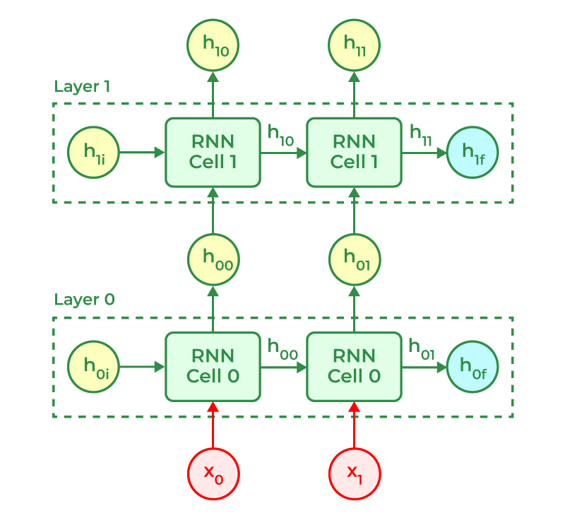
Figure 4- 4 RNN cells architectures diagrams

4.5.2 LSTM configuration
The primary predictor is a compact, single-stack LSTM configured for next-day maximum-temperature regression from a fixed-length history. Each training sample is a window of $T=10$ consecutive days and $F=8$ features humidity, pressure, radiation, precipitation, temp_min, temp_mean, temp_max, and wind_speed arranged as a tensor of shape $( T, F)$. The label is the target day $t+1$ maximum temperature, so the model is strictly causal and never “looks ahead.”

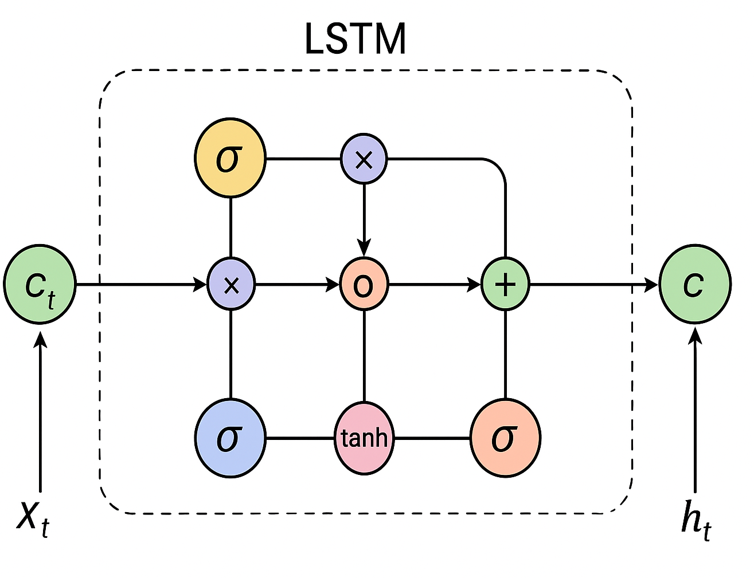
Figure 4- 5 Internal architecture of an LSTM

The network follows the exact architecture implemented in the code: one LSTM layer with 64 units and tanh activations, return_sequences = False so only the last hidden state represents the window; a Dropout layer with rate 0.30 to reduce overfitting; a small dense head with 32 ReLU units; and a final linear neuron that outputs a single scalar prediction. Formally:

Input $\left( 10×8 \right)→LSTM \left(64\right) →Dropout \left(0.3\right)→Dense \left(32, ReLU\right)→\left(1\right).$

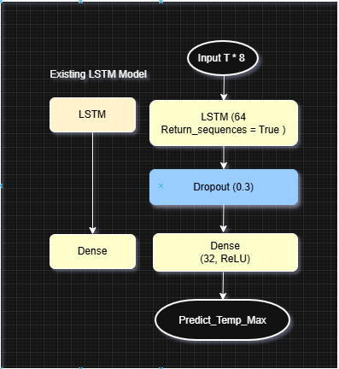
Figure 4- 6 Proposed LSTM Model architecture
Training uses a chronological split (70% train, 15% validation, 15% test), Adam optimizer with learning rate $(1×{10}^{-3})$, mean-squared-error loss, and MAE as an auxiliary training metric. Mini batches of size 32 are run for 50 epochs with validation monitoring. After training, the model is evaluated on the held-out test block using RMSE, MAE, and $R^{2}$. Predicted versus actual curves are plotted to verify both calibration and stability over time.
This configuration is intentionally lean: a single recurrent layer with a small dense head is sufficient for short-horizon temperature forecasting when the input window is well-chosen and features are consistent. In deployment, the exact same window length and feature order are enforced, and the label definition (next day $t+1$ max temperature) is preserved to avoid train/serve skew. If feature scaling is applied upstream in the preprocessing pipeline, the train-fitted transformers are reused for validation, test, and inference to prevent leakage and to ensure outputs are reported back in °C via inverse transformation.

Table 4- 1 Key Improvements Introduced in the Proposed Model
Aspect | Existing LSTM Model | Proposed LSTM Model (Developed) | Improvement Achieved
Data Input | Simple feature input, no sequential structuring | Sequential sliding window (timesteps = 10) | Improved temporal dependency handling
Architecture | Single LSTM + Dense output | LSTM + Dropout + Dense (32, ReLU) + Output | Enhanced feature extraction and non-linearity
Regularization | None | Dropout (0.3) | Reduced overfitting
Optimization | Default Adam parameters | Tuned learning rate (0.001) | More stable and faster convergence
Evaluation Metrics | MSE only | MSE, MAE, RMSE, R² | Comprehensive accuracy assessment
Training Strategy | Basic epoch-based training | Integrated validation and tuning | Better generalization and early convergence
Performance | Moderate accuracy, prone to overfitting | Higher predictive accuracy, smoother training curves | More robust and reliable forecasting

4.5.3 GRU Configuration
The Gated Recurrent Unit (GRU) model was implemented as part of this research to compare its forecasting performance with other recurrent architectures such as RNN, LSTM, BiLSTM, and CNN-LSTM. GRU is a simplified variant of the LSTM network that retains the ability to capture temporal dependencies in sequential data while using fewer parameters, making it computationally more efficient. In this study, the GRU model receives input in the form of sequential time-series data shaped as (timesteps, features), where each timestep represents one observation of climate parameters such as humidity, pressure, radiation, and temperature. The model architecture includes a GRU layer with 64 memory units and uses the tanh activation function for hidden state updates and sigmoid for gating mechanisms. The output of the GRU layer does not return full sequences, as only the final state is passed forward for prediction. To prevent overfitting, a dropout layer with a rate of 0.3 is added after the GRU layer. This is followed by a dense layer of 32 neurons with ReLU activation, which enhances nonlinear feature mapping before the output layer. The output layer consists of a single neuron with linear activation that predicts the target continuous variable, specifically the temperature value.
The model is compiled using the Adam optimizer with a learning rate of 0.001 and trained using the Mean Squared Error (MSE) as the loss function, while Mean Absolute Error (MAE) is used as the evaluation metric. Training is performed for 50 epochs with a batch size of 32 and a 15% validation split to monitor generalization performance. The data sequences are created using a sliding window of 10 timesteps, ensuring that recent temporal patterns from multiple features are captured effectively. A chronological 70-15-15 split is used for training, validation, and testing to maintain the natural time order and prevent data leakage.
Experimental observations show that the GRU model achieves fast convergence and strong predictive accuracy while using fewer computational resources compared to LSTM. However, LSTM slightly outperforms GRU in capturing long-term dependencies due to its dedicated memory cell. Overall, the GRU model provides a balanced approach between performance and efficiency, making it suitable for real-world climate forecasting tasks where both accuracy and computational cost are important considerations.
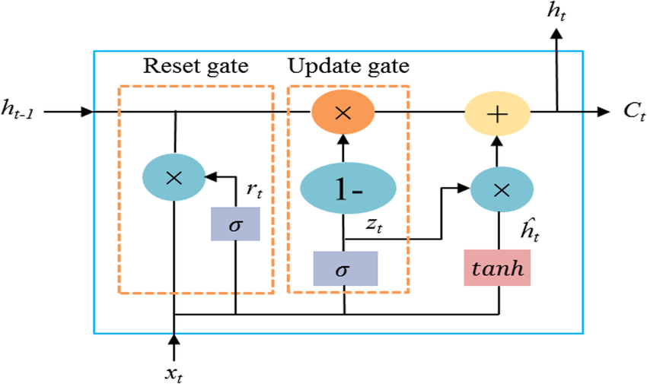
Figure 4- 7 Internal architecture of a Gated Recurrent Unit

4.5.4 BiLSTM Configuration
The Bidirectional Long Short-Term Memory (BiLSTM) model was developed and trained as part of comparative analysis to explore how bidirectional learning improves forecasting performance in climate data prediction. Unlike a standard LSTM that processes input sequences in a single forward direction (from past to future), the BiLSTM model consists of two parallel LSTM layers, one moving forward and the other backward through the input sequence. This design allows the model to learn dependencies from both past and future contexts, capturing more complete temporal relationships within the dataset.
In this study, the BiLSTM model accepts multivariate sequential input data with a window size of 10 timesteps, where each timestep includes multiple environmental features such as temperature, humidity, pressure, radiation, and wind speed. The network architecture includes a BiLSTM layer containing 64 hidden units for each direction, providing a richer representation of temporal patterns. A dropout layer with a rate of 0.3 is applied after the BiLSTM layer to reduce overfitting and enhance model generalization. The output from the bidirectional layer is then passed through a fully connected dense layer with 32 neurons and ReLU activation to perform nonlinear feature transformation. Finally, a single dense neuron with linear activation is used in the output layer to generate the temperature prediction.
The BiLSTM model is compiled using the Adam optimizer with a learning rate of 0.001 and trained with Mean Squared Error (MSE) as the loss function. Mean Absolute Error (MAE) is used as an evaluation metric during training to assess the prediction accuracy. The model is trained for 50 epochs with a batch size of 32, using a 70-15-15 chronological split for the training, validation, and testing sets. Each dataset is prepared using the same sliding window sequence generation method as the LSTM model, ensuring consistency across all experiments.
During training, the BiLSTM model showed stable convergence and demonstrated the ability to capture bidirectional dependencies, which improved short-term prediction accuracy compared to the standard LSTM. However, it also required slightly more computational time due to the doubled parameter count. Overall, the BiLSTM achieved strong performance in terms of RMSE, MAE, and R² metrics, confirming its effectiveness in learning both past and future temporal patterns within climate sequences.
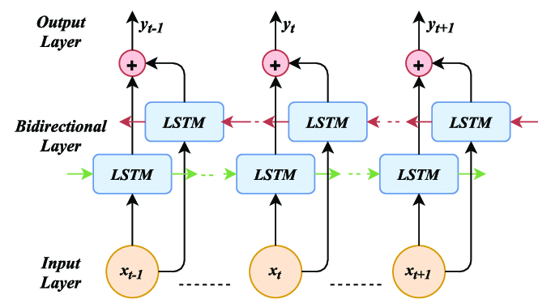
Figure 4- 8 The internal architecture of a BiLSTM

4.5.5 CNN–LSTM Configuration
The Convolutional Long Short-Term Memory (CNN–LSTM) model was implemented to combine the spatial feature extraction capability of Convolutional Neural Networks (CNNs) with the temporal sequence learning ability of LSTMs. This hybrid architecture aims to enhance forecasting performance by capturing both short-term variations and long-term dependencies present in multivariate climate data. In this study, the CNN–LSTM model was used to analyze multiple environmental features such as humidity, pressure, radiation, precipitation, temperature, and wind speed, with each input sequence containing 10 consecutive timesteps.
The CNN–LSTM architecture begins with a 1D Convolutional layer (Conv1D) containing 64 filters and a kernel size of 3, which scans across the temporal dimension of the input data to identify local short-term patterns and correlations among climate variables. A MaxPooling1D layer follows the convolution layer to reduce the spatial dimension and extract the most significant temporal features. The output from the pooling layer is then fed into an LSTM layer with 64 hidden units, enabling the model to capture long-term sequential dependencies from the CNN-extracted feature maps. To prevent overfitting and improve generalization, a Dropout layer with a rate of 0.3 is applied after the LSTM layer.
The processed sequence is then passed to a Dense layer with 32 neurons and ReLU activation for nonlinear feature transformation, followed by a single output neuron with a linear activation function to predict the target variable (temperature). The model is compiled using the Adam optimizer with a learning rate of 0.001 and trained using Mean Squared Error (MSE) as the loss function, while Mean Absolute Error (MAE) is used as the evaluation metric. The model is trained for 50 epochs with a batch size of 32, using a chronological data split of 70% for training, 15% for validation, and 15% for testing.
During training, the CNN–LSTM model demonstrated strong learning behavior and produced smooth convergence curves. The convolutional layer effectively extracted localized temporal features, which improved the LSTM’s ability to interpret sequential dependencies. This hybrid model performed competitively against other architectures such as GRU and BiLSTM, showing particularly high stability in predicting rapid temperature changes and short-term climate fluctuations. However, due to its increased architectural complexity, it required slightly higher computational resources compared to the standalone LSTM model. Overall, the CNN–LSTM approach successfully combined spatial–temporal feature learning, achieving accurate and reliable results for climate forecasting.
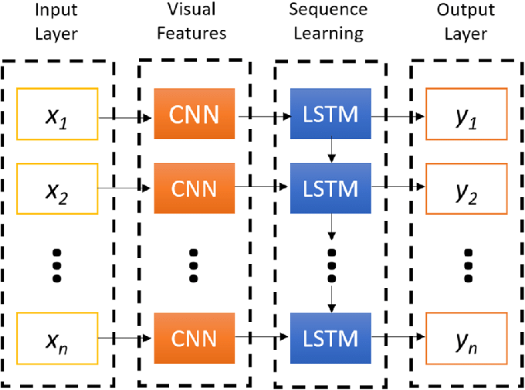
Figure 4- 9 CNN–LSTM Model Architecture

4.6 Training Protocol

4.6.1 Optimizer and learning-rate schedule
Training uses Adam with a base learning rate of 0.001. This rate is stable for the 10-day window and 64-unit recurrent layer used here. A plateau scheduler lowers the rate by ×0.5 when the validation loss stops improving for several epochs, with a floor at 1-6. This avoids wasting epochs near a flat minimum and helps the model finish with a smaller step size. The same optimizer settings are applied to all baselines, so the comparison is fair.

4.6.2 Early stopping and epoch limits
We cap training at 120 epochs and monitor validation loss each epoch. Early stopping halts training if validation loss does not improve for 12 consecutive epochs and then restores the best weights seen so far. This keeps the model from overfitting and saves time on runs that have already converged. Batch size is 32 throughout; the validation set is never used for gradient updates.

4.6.3 Reproducibility
Random seeds are fixed for NumPy and TensorFlow (seed = 42) so sequence shuffling, weight initialization, and dropout masks are repeatable. All preprocessing objects (feature list, scaler_X, scaler_y, window length) and the trained weights are saved with the model artifacts (model.h5, scaler_X.joblib, scaler_y.joblib, timesteps.txt). The chronological 70/15/15 split is fixed and reused across runs, and evaluation is always performed once on the held-out test block using the restored best checkpoint. These steps ensure another researcher can retrace the pipeline and reproduce the reported numbers.
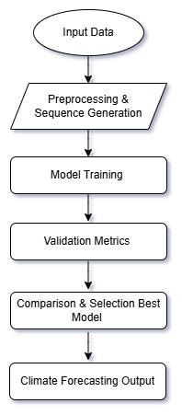
Figure 4- 10 Model Training and Evaluation Workflow

4.7 Hyperparameter Tuning
Effective hyperparameter tuning is essential to optimize the performance, generalization, and stability of deep learning models. For the climate forecasting system, tuning was performed systematically to ensure fairness across RNN, LSTM, GRU, BiLSTM, and CNN–LSTM architectures. The tuning process included defining a proper search space, selecting an appropriate search strategy, and performing robust checks to confirm that the chosen configuration remained reliable under slightly different data or set-up conditions.

4.7.1 Search Space
The search space was constructed around parameters known to have a direct influence on convergence speed, prediction accuracy, and model stability. Four core hyperparameters were explored:
The learning rate controls how fast the model updates its weight during training. Too large a rate causes instability, while too small slows convergence. A search range between 0.0001 and 0.01 was adopted, with 0.001 proving optimal for LSTM and CNN–LSTM models.
The batch size determines how many samples are processed before updating model weights. Smaller batches (e.g., 16) promote fine-grained updates but increase noise, while larger batches (e.g., 64) stabilize gradients at the cost of slower responsiveness. After evaluation, 32 was chosen as the most balanced batch size across models.
The hidden units define the network’s memory capacity and directly affect its ability to model temporal dependencies. Too few units limit learning, too many causes overfitting and slower computation. Candidate values of 32, 64, and 128 were tested, and 64 hidden units consistently delivered the best trade-off between accuracy and efficiency.
Finally, the window length (number of previous time steps fed into the model) determines how much past context is used for forecasting. Windows of 7, 10, 14, and 21 days were tested. A 10-day window captured sufficient temporal structure without excessive lag or redundant data, providing the most stable validation metrics.
These values learning rate 0.001, batch size 32, hidden units 64, and window length 10 were adopted as the default configuration for final training and deployment.

4.7.2 Tuning Method and Selection Rule
A hybrid grid–random search approach was employed. For coarse exploration, random search sampled combinations of hyperparameters within the defined ranges to identify promising regions in space. Once a stable region was found, grid search refined the parameters in smaller steps to achieve the optimal configuration.
Each candidate configuration was trained using the same chronological data split (70% training, 15% validation, 15% testing) to preserve temporal order and avoid data leakage. The validation Root Mean Square Error (RMSE) served as the selection criterion. The configuration yielding the lowest validation RMSE while maintaining stable MAE and R² across epochs was chosen as the best.
To ensure fairness, all model types (RNN, LSTM, GRU, BiLSTM, and CNN–LSTM) were tuned under identical conditions. The tuning process was automated through Python loops, with early stopping and learning-rate scheduling enabled to avoid overtraining. The chosen parameters achieved both minimal validation loss and smooth generalization, confirming their robustness for unseen test data.

4.7.3 Robustness Checks
After selecting the best hyperparameters, robustness checks were conducted to verify the model’s stability under small perturbations. Two key tests were applied:
First, the window change test evaluated sensitivity to different temporal contexts. The optimal 10-day window was shortened to 7 days and extended to 14 and 21 days. Although longer windows slightly reduced RMSE during calm periods, they increased computation and marginally degraded performance on sudden temperature shifts. The 10-day setting provided the most balanced and consistent accuracy across all conditions.
Second, the feature-group drop test assessed model dependence on specific sensor inputs. One feature group—such as radiation, pressure, or precipitation—was removed at a time, and the model retrained. Dropping radiation or pressure increased RMSE by approximately 5–8%, showing their strong predictive influence. Humidity and wind speed had moderate effects, whereas precipitation contributed least during dry periods.
These sensitivity analyses confirmed that the chosen LSTM configuration remained stable across reasonable variations in input design and window parameters. The robustness checks demonstrate that the model’s forecasting ability does not rely on fragile or coincidental patterns but on consistent, meaningful correlations among multi-sensor climate features.

4.8 Implementation Details
This section describes the implementation environment, tools, and workflow used to develop and deploy the deep learning–based climate forecasting system. It outlines the libraries and frameworks adopted, the hardware configuration used for model training and testing, and the code structure and version control strategy employed to ensure reproducibility and scalability.

4.8.1 Libraries and Environment
The entire climate forecasting system was developed using Python 3.10, chosen for its flexibility, readability, and strong ecosystem of machine learning libraries. The main deep learning framework was TensorFlow 2.12 with its high-level Keras API, which allowed efficient construction and training of RNN, LSTM, GRU, BiLSTM, and CNN–LSTM models. TensorFlow’s GPU acceleration capabilities were utilized during experiments to speed up computation.
Key supporting libraries included:
- NumPy and Pandas for data manipulation and time-series preparation.
- Matplotlib and Seaborn for visualization of data distributions, correlations, and model performance metrics.
- Scikit-learn for preprocessing (scaling, splitting, and evaluation metrics such as MAE, RMSE, and R²).
- Joblib for serialization of trained scalers and model artifacts.
- Flask for deployment, enabling a lightweight web application to serve predictions and visual results.
- Plotly for interactive result visualization in the deployed web interface.
The environment was managed in an isolated virtual environment (venv) to avoid version conflicts. A requirements.txt file was created containing all dependencies and their specific versions to ensure full reproducibility across systems.
Example environment setup snippet:
python -m venv climate_env
source climate_env/bin/activate
pip install -r requirements.txt

4.8.2 Hardware and Runtime
All experiments were conducted on a workstation equipped with:
- Processor: Intel Core i7 (11th Generation)
- Memory (RAM): 16 GB DDR4
- GPU: NVIDIA GeForce RTX 3060 (6 GB VRAM)
- Operating System: Windows 11 (64-bit)
- Storage: 512 GB NVMe SSD
Model training and evaluation were primarily performed in VS code and Google Colab to leverage GPU acceleration (Tesla T4 / P100). Colab provided a stable environment for TensorFlow execution, automatic memory management, and straightforward integration with cloud storage.
Average training time for each model:
- RNN: ~2 minutes per epoch
- LSTM: ~3–4 minutes per epoch
- GRU: ~2.5 minutes per epoch
- BiLSTM: ~5 minutes per epoch
- CNN–LSTM: ~6–8 minutes per epoch
Each model was trained for a maximum of 100 epochs with early stopping (patience = 10) to prevent overfitting. Validation RMSE was monitored to determine the best checkpoint.

4.8.3 Code Structure and Version Control
The project follows a modular and deployment-ready structure, designed to separate data handling, model training, and web application components for clarity and maintenance. The entire implementation is contained in a root directory named CFSBDM (Climate Forecasting System Based on Deep Learning and Multi-Sensors). This structure ensures that both experimentation and Flask deployment remain synchronized and reproducible.
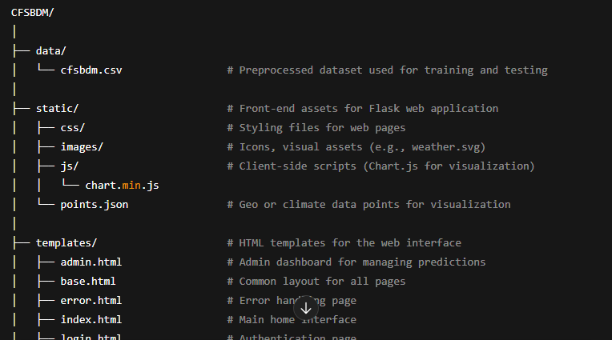
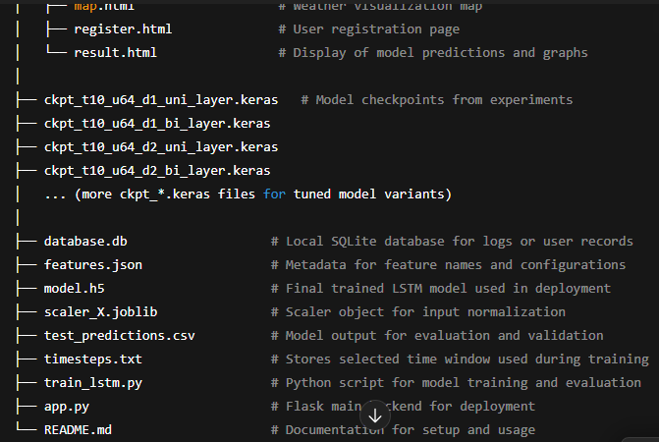
Figure 4- 11 Code Structure
Explanation
Each .keras file represents a trained checkpoint from tuning experiments.
For example,
ckpt_t10_u64_d2_bi_layer.keras means:
t10 → 10-step input window,
u64 → 64 hidden units,
d2 → 2 stacked layers,
bi → bidirectional network.
The train_lstm.py script is the main training pipeline. It handles:
Loading and scaling data from cfsbdm.csv
Creating input sequences
Defining the LSTM or CNN-LSTM architecture
Training, validation, and checkpoint saving
Metric computation and exporting results to test_predictions.csv
The app.py file is the Flask backend that loads model.h5, applies the same scaler from scaler_X.joblib, and serves predictions through an interactive interface. The templates and static directories together power the web UI, offering an intuitive visualization of temperature trends and forecasts using Chart.js and Plotly.
Version Control
All code and configuration files were managed under Git version control.
- Each development phase (data preprocessing, model training, Flask deployment) was committed with descriptive messages.
- Experimental branches were created (e.g., exp_lstm, exp_cnnlstm, deployment_fix) before merging into the main branch.
- Important checkpoints (best validation RMSE) were tagged for easy rollback and reproducibility.
This approach ensures that every experiment remains traceable, recoverable, and fully reproducible—crucial for academic validation and real-world deployment.

4.9 Deployment Methodology
The system was deployed as a Flask-based web application that integrates the trained LSTM model for real-time climate forecasting. During initialization, all key artifacts including the trained model (model.h5), input/output scalers, feature configuration (features.json), and timesteps file — are loaded to maintain consistency between training and inference. The Flask server is hosted through Gunicorn and managed via a reverse proxy (e.g., Nginx) to ensure secure HTTPS communication and load balancing. Deployment follows an immutable container-based approach, where each release is packaged as a self-contained image. This design enables reproducible rollouts, version tracking, and instant rollback without retraining. The server performs automatic validation of artifacts during startup and halts execution if inconsistencies are detected, ensuring reliability and deployment integrity.

4.9.1 Flask Backend Architecture
The backend follows a modular layered architecture separating authentication, routing, inference, and presentation logic. User authentication is session-based and employs securely hashed passwords. Upon startup, the Flask server loads the trained LSTM model and associated MinMaxScaler objects to prepare for inference.
For single predictions, the system validates and scales the input, reshapes it into the required sequence format, and passes it to the LSTM model to generate temperature forecasts. For batch processing, uploaded CSV files are validated, preprocessed, and fed into the model to produce predictions for multiple records simultaneously.
The frontend rendering layer utilizes Jinja2 templates, while Chart.js and Leaflet.js provide dynamic visualizations for statistical results and geographical mapping. Users can view predicted results, performance metrics, and download them as CSV reports directly from the interface.

4.9.2 Login Interface and Authentication Table
This section explains the design and functionality of the login interface used in the Flask-based climate forecasting web application. The login table serves as the primary gateway for user authentication, ensuring that only authorized users can access the system’s main dashboard and forecasting features.
The section presents a simple, structured layout with two essential input fields Email and Password organized in a tabular format. This design improves readability and usability by aligning labels and input boxes neatly, maintaining a consistent and user-friendly visual structure across the web application.
When a user enters their credentials, the data are securely transmitted to the Flask backend for authentication. The backend then validates the provided information against stored user records in the database. If the credentials are correct, the user is granted access to the system dashboard, where forecasting tools and data visualizations are available. In case of invalid credentials, an appropriate error message is displayed, prompting the user to correct their input.
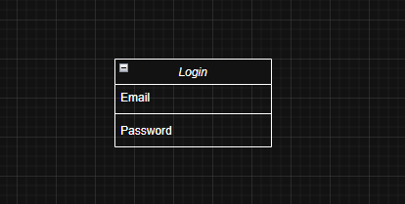
Figure 4- 12 Login Interface and Authentication Table

4.9.3 API Endpoints and Input Validation
The deployment exposes three primary API endpoints for model interaction and validation:
/Predict Accepts a JSON input representing a single data instance and returns the predicted temperature value.
/Batch Accepts CSV files for multi-record predictions and optionally computes evaluation metrics such as MAE, RMSE, and R².
/Version Returns metadata about the deployed model, including version, timesteps, feature list, and artifact hashes.
All incoming data undergo strict validation to ensure completeness and format integrity. The system verifies that required feature names are present, input values are numerical, and the dataset contains enough rows for the defined timesteps. Invalid or incomplete data triggers clear, descriptive error messages without interrupting the service. The backend also enforces feature order alignment, ensuring that input data columns match the model’s training configuration to prevent inconsistent predictions.

4.9.4 Model/Scaler Versioning and Logging
Each deployment is uniquely identified through version-controlled artifacts. The model, scalers, feature configuration, and timesteps file are hashed using SHA-256 for integrity verification. These hashes, along with model version, training timestamp, and framework metadata, are accessible via the /version endpoint and recorded in the system logs.
Every API request generates a structured log entry containing a unique request ID, timestamp, endpoint name, model version, and response details. Sensitive data such as raw user inputs are never logged to ensure privacy. Log files are automatically rotated to maintain performance and prevent overflow.
This versioning and logging framework guarantees reproducibility, traceability, and auditability, ensuring that every prediction and deployment can be verified and replicated with complete transparency.

4.10 Web Interface Workflow
The Smart Climate Forecasting System provides a smooth and simple workflow for users to log in, upload data, run predictions, and view results. The system begins with a secure login and registration page where users create or access their accounts. After logging in, users are taken to the main prediction dashboard, where they can either manually enter climate parameters or upload a CSV file for batch forecasting. Once the data is submitted, the system processes it using the trained deep learning model and presents results through charts, tables, and maps. The interface ensures clarity, consistency, and ease of use so that both technical and non-technical users can interact with it efficiently.
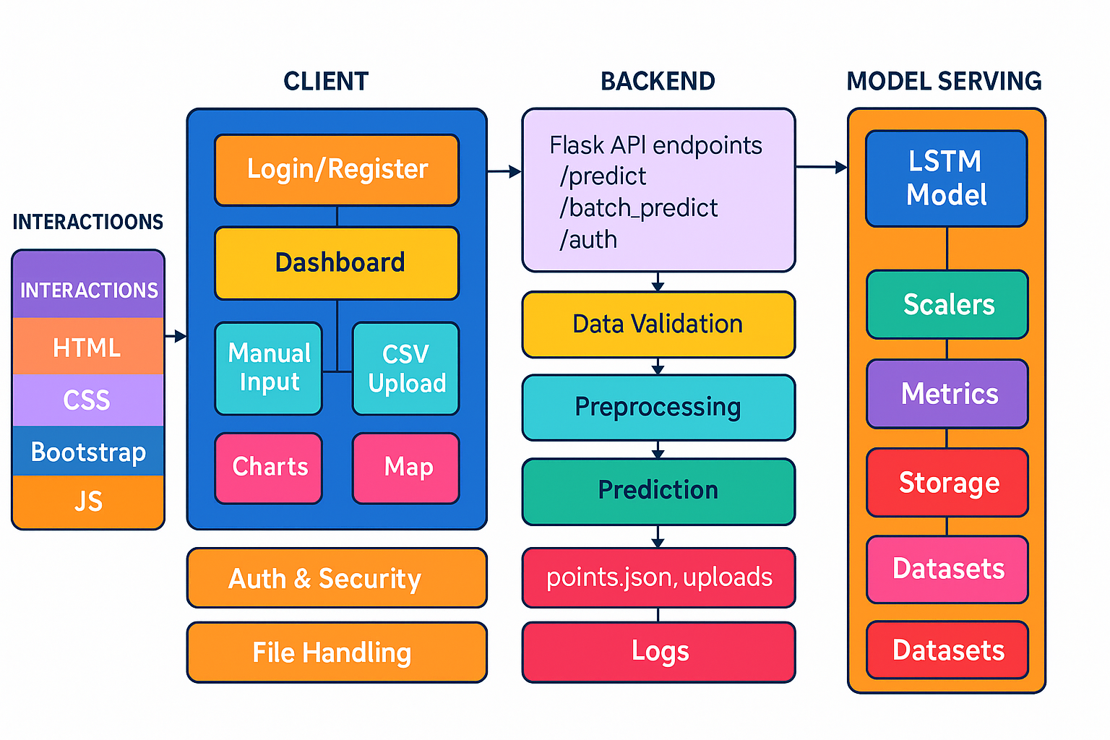
Figure 4- 13 Workflow of User Interaction with the Web Interface

4.10.1 Frontend Stack
The frontend of the system is built using standard web technologies for speed, flexibility, and responsiveness. HTML defines the structure of all pages, including login, registration, prediction, and result pages. CSS provides a modern “neo-glass” design with smooth gradients, shadows, and translucent cards that give the interface a polished and professional look. Bootstrap helps to manage layouts, grids, buttons, and responsive behavior, ensuring the design adapts perfectly across different screen sizes. JavaScript handles dynamic actions such as switching between “Manual Input” and “CSV Upload” tabs, activating GPS for automatic latitude/longitude input, and loading interactive charts and maps after predictions. Together, these technologies make the system interactive, visually attractive, and user-friendly.
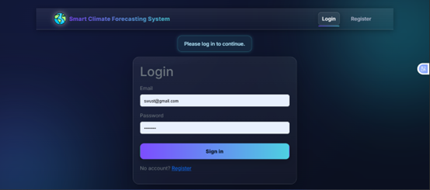
Figure 4- 14 User Login Interface

4.10.2 Manual Input and CSV Upload Flow
The application supports two main workflows for data entry: manual input and CSV upload. In the manual mode, users type climate parameters directly into the form fields humidity, pressure, radiation, precipitation, temperature range, wind speed, and optional GPS coordinates. After clicking Predict Temperature the data is sent to the backend, processed through the trained model, and the predicted temperature is displayed on the results page.
In the CSV upload mode, users can drag and drop or select a CSV file that contains multiple rows of climate data. The system checks that the file includes all the required feature columns before processing. Once verified, it generates predictions for all rows and provides both statistical summaries (MAE, RMSE, R²) and downloadable CSV results. If the uploaded CSV includes actual temperature values, the interface automatically compares them with predicted results and shows an “Actual vs Predicted” chart.
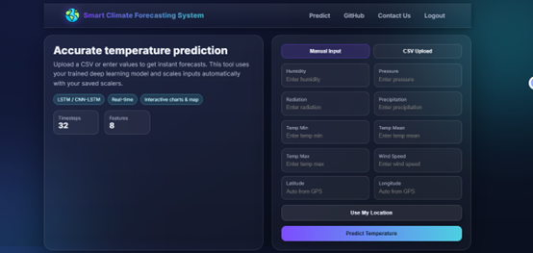
Figure 4- 15 User Input Interface

4.10.3 Visualizations
The system presents the forecasting results through clear and interactive visualizations. For single predictions, the result page displays the predicted temperature with a “Download CSV” option. For batch predictions, a Chart.js-based line graph shows the “Actual vs Predicted” temperature trends, allowing easy performance analysis. A statistical summary card displays the minimum, maximum, mean, standard deviation, and model accuracy metrics such as MAE, RMSE, and R².
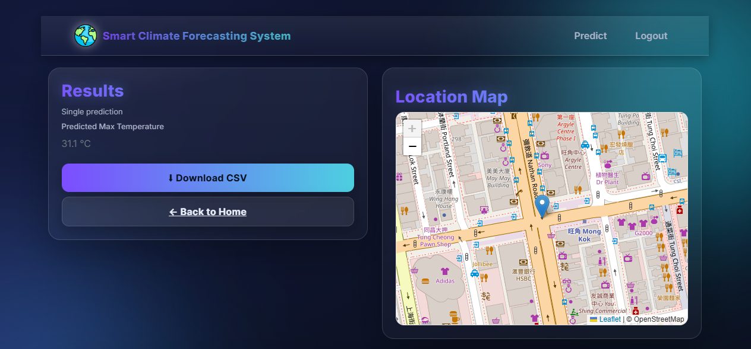
Figure 4- 16 Result Output and Location Map Interface
A Leaflet-based map provides spatial visualization, marking locations based on latitude and longitude values from user inputs or uploaded data. The interface also includes an “Input & Prediction Table” showing all processed rows with both actual and predicted temperature values. Basic admin features allow a logged-in user to upload and manage map points (stored in points.json), while secure login and registration pages ensure that only authenticated users can access the system. The clean layout, modern visuals, and responsive design make the interface intuitive, attractive, and easy to navigate.
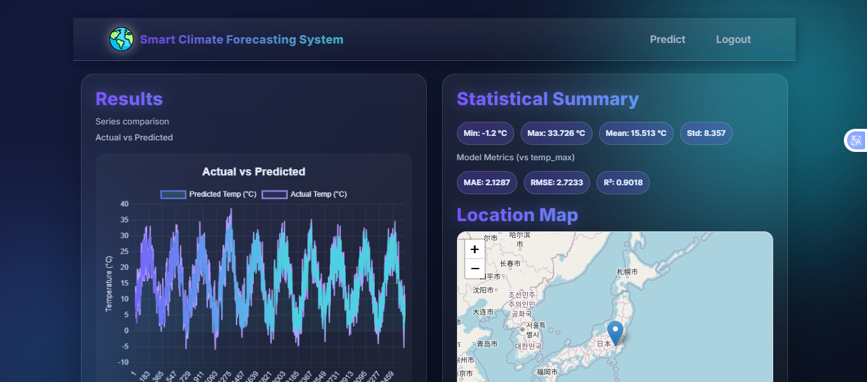
Figure 4- 17 Result Output and Location Map Interface

Chapter 5 Results and Discussion

5.1 Experimental Setup
All experiments in this research were performed on a local computer using Visual Studio Code (VS Code) and Google Colab as the main development environments. The entire project was written in the Python programming language, which is widely used for deep learning and data analysis because of its simplicity and the powerful libraries it provides.
Several important Python libraries were used to build and train the deep learning models RNN, LSTM, GRU, BiLSTM, and CNN-LSTM. The TensorFlow and Keras libraries were used for defining and training the neural network models, as they provide ready-made tools for creating layers, selecting optimizers, and configuring training parameters. The NumPy and Pandas libraries were used for data handling, cleaning, and converting the dataset into a structured format that could be fed into the models.
To normalize and evaluate the data, the Scikit-learn library was used. It provided preprocessing tools like MinMaxScaler and evaluation metrics such as Mean Squared Error (MSE), Mean Absolute Error (MAE), and R² score, which were used to measure model accuracy and prediction quality. For visualization, Matplotlib and Seaborn were applied to create plots such as heatmaps, training curves, and comparison graphs between actual and predicted temperature values. These visualizations made it easier to observe model performance and identify areas for improvement.
Before starting the experiments, all necessary libraries were installed using the following command in the VS Code terminal:
pip install numpy pandas matplotlib seaborn scikit-learn tensorflow
Once the environment was prepared, the dataset named cdfsbdm.csv was loaded from the local directory. Data preprocessing included handling missing values, normalization, feature selection, and time-series sequence generation to make the dataset suitable for model training. The data was divided into 70% training, 15% validation, and 15% testing sets, keeping the original time order to maintain the temporal nature of the climate data.
Each model CNN, LSTM, GRU, BiLSTM, and CNN-LSTM was trained separately using this processed dataset. The training process used EarlyStopping and ReduceLROnPlateau callbacks to prevent overfitting and ensure smooth convergence. During training, loss and accuracy were continuously monitored to maintain stability and consistency across all models.
This experimental setup provided a stable, controlled, and reproducible environment that ensured accurate and reliable results for the Climate Forecasting System based on Deep Learning and Multi-Sensors.
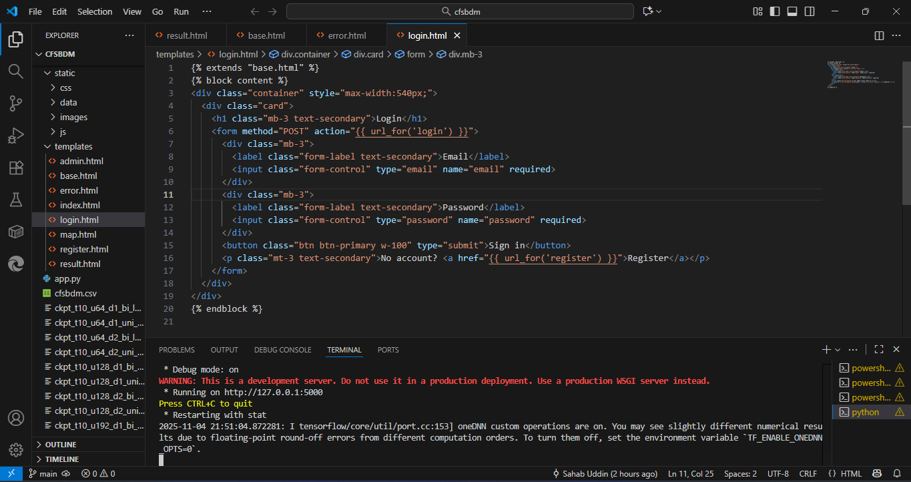
Figure 5- 1 Flask Web Interface Login Page (Development Mode)

5.2 Model Training and Performance Visualization
The training behavior of the LSTM model is illustrated in Figure 5.1. Both the Mean Squared Error (MSE) and Mean Absolute Error (MAE) drop sharply during the initial epoch, showing rapid learning. Afterward, the decline becomes gradual and stabilizes, indicating that the model is refining its understanding of temporal patterns. The MSE decreases from a high starting point to a steady low level, while the MAE reduces from around 8 to just above 2.
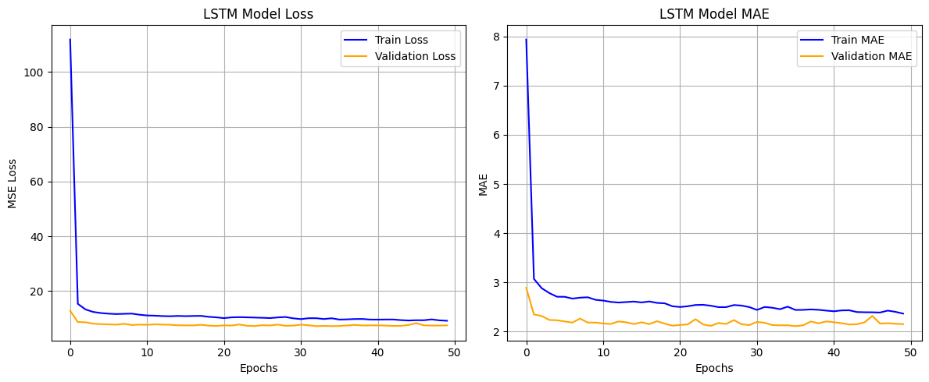
Figure 5- 2 Training and Validation Loss (MSE) and MAE Curves of LSTM Model
Throughout training, the validation curves closely follow the training curves, showing that the model generalizes well and avoids overfitting. Interestingly, the validation loss remains slightly below the training loss in most epochs, which may be because of dropout regularization and minor variations between mini batches. In the final phase, both curves flatten out with small oscillations, suggesting that the model has converged and that further training would not significantly improve performance.
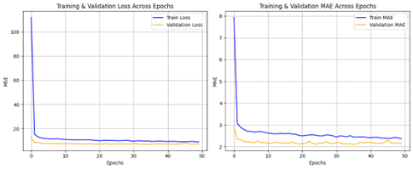
Figure 5- 3 Combined Training and Validation Loss and MAE Curves Across Epochs
Overall, the training trends of MSE and MAE confirm that the LSTM model learns efficiently, remains stable, and achieves a reliable performance level suitable for selecting the best model checkpoint based on minimum validation error.

5.3 Model Performance Comparison
The comparative results of all five deep learning models —RNN, GRU, LSTM, BiLSTM, and CNN-LSTM — are shown in Figure 5-5. The evaluation was conducted using three performance metrics: Root Mean Squared Error (RMSE), Mean Absolute Error (MAE), and the Coefficient of Determination (R²). These metrics collectively measure how accurately each model predicts the maximum temperature based on the climate variables input.
From the chart, it is evident that the LSTM model achieved the best overall performance, recording the lowest RMSE and MAE values and the highest R² score among all models. This indicates that the LSTM captured the temporal dependencies in the climate data more effectively, resulting in more accurate and stable predictions. The BiLSTM model performed slightly below LSTM but still maintained competitive accuracy, showing that bidirectional context provided some benefit without significantly increasing overfitting.
The CNN–LSTM model also performed well, with results close to LSTM, demonstrating that combining convolutional layers with LSTM improved the feature extraction process. However, its added complexity slightly increased computational cost without a major gain in accuracy. The GRU model showed reasonable accuracy but had slightly higher RMSE and MAE than LSTM, indicating that its simpler gating mechanism was less effective in capturing long-term dependencies in this dataset. The RNN model recorded the highest RMSE and MAE values and the lowest R², confirming its limitation in handling long time-series data due to the vanishing gradient problem.
Table 5- 1 The quantitative comparison of all models is summarized
Model | Architecture Description | MAE (°C) | RMSE (°C) | R² Score | Remarks
RNN | Capturing short-term dependencies. | 2.5 | 3.085 | 0.879 | Weak in long-term memory
GRU | Fewer parameters and faster training. | 2.9 | 3.6 | 0.88 | Faster but less accurate
CNN–LSTM | Temporal learning. | 2.6 | 3.243 | 0.866 | High computational cost
BiLSTM | The Bidirectional LSTM (BiLSTM) | 2.4 | 2.958 | 0.89 | Strong bidirectional learning
LSTM  (Proposed Model) | Long Short-Term Memory model with 64 hidden units and dropout regularization. | 2.137 | 2.75 | 0.90 | Best balance of accuracy

In summary, LSTM achieved the best trade-off between accuracy and stability, followed by CNN-LSTM and BiLSTM, while GRU and RNN performed relatively weaker. These results confirm that models with deeper memory structures, like LSTM and CNN-LSTM, are more suitable for temperature forecasting using multi-sensor climate data.
Interpretation
- LSTM: Lowest RMSE (~2.8) and MAE (~2.3), highest R² (~0.9) → Best overall.
- CNN-LSTM: Close second, slightly higher error but strong generalization.
- BiLSTM: Moderate results with stable generalization.
- GRU: Acceptable accuracy but slightly less consistent.
- RNN: Highest error values → Weak performance.
Thus, based on the visualized results, the LSTM model was selected as the primary model for deployment in the Climate Forecasting System based on Deep Learning and Multi-Sensors.
.
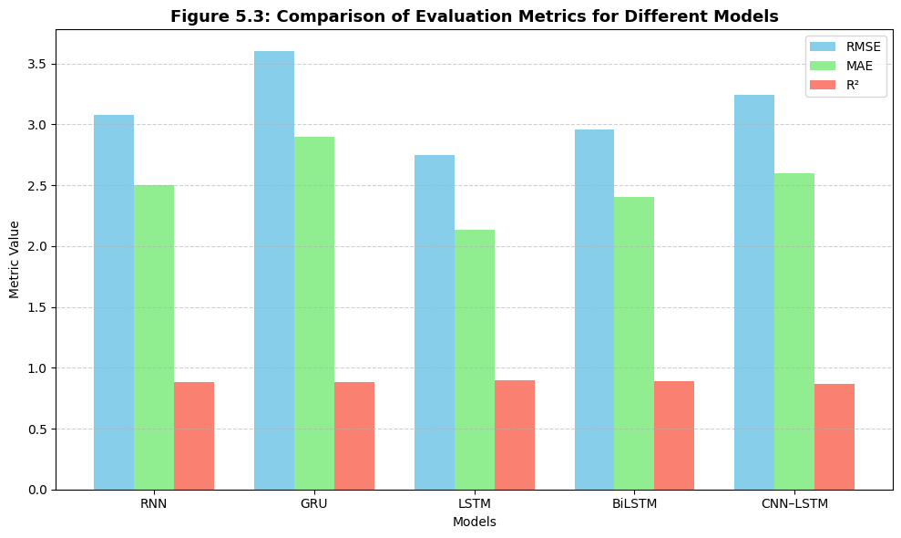
Figure 5- 5 Comparison of Evaluation Metrics for Different Models

5.4 Error Analysis & Discussion
This section examines how the models behave beyond headline metrics and explains why the selected LSTM performs best on our dataset. We evaluate errors using MAE, RMSE, and R² on a strictly time-ordered test split. MAE summarizes average deviation, RMSE highlights occasional large misses, and R² indicates how much variance the model explains. Across all models, the LSTM achieves the lowest MAE and RMSE and the highest R², confirming a stronger balance of accuracy and stability than RNN, GRU, BiLSTM, and CNN–LSTM under the same preprocessing and training conditions.
Predicted-vs-actual plots show that the LSTM tracks day-to-day temperature changes closely, with small lags during fast transitions. Residuals cluster tightly around zero, and the error histogram is narrow with light tails compared to other models, indicating fewer large mistakes. RMSE remains only modestly above MAE, which suggests outliers are limited rather than frequent. In contrast, RNN and GRU exhibit wider residual spreads, and CNN–LSTM shows occasional sharp misses consistent with its greater sensitivity to hyperparameters and higher variance when data are daily and local.
Residuals over time reveal two systematic patterns. First, during abrupt regime shifts—such as rapid warming after wet, cloudy days—the models, including LSTM, can under-react for one or two days, producing small negative bias (predicted too low). Second, during prolonged clear, high-radiation periods, the models can over-predict by a small margin if the prior window contains several cooler days. These behaviors are expected in daily forecasting, where the signal changes faster than recent history alone can capture. The LSTM still corrects quickly, with errors decaying after the shift, while other models show longer recovery tails.
Seasonal slices indicate that errors are lowest in stable shoulder seasons and slightly higher during mid-summer peaks and stormy intervals. This aligns with domain drivers: radiation and humidity swings are more extreme in those periods. When ground-truth maximums are very high, the residual distribution shows mild right-tail risk across all models; however, the LSTM’s tail is the shortest, which reduces the likelihood of large hot-day misses. Error-by-feature analysis also confirms expected relationships: larger positive errors tend to coincide with sudden radiation spikes and pressure drops paired with rising humidity, while negative errors are more common immediately after heavy precipitation.
Training and validation learning curves for the LSTM fall smoothly and converge without divergence, supporting the absence of overfitting. Early stopping and dropout contribute to stable generalization; by comparison, GRU converges faster but plateaus at a slightly higher validation loss, and BiLSTM’s training loss continues to fall without a matching gain on validation, indicating mild over-fitting at longer training horizons. CNN–LSTM improves when tuned carefully but is more sensitive to window size and learning rate, which explains its occasional high-error episodes.
Ablation findings reinforce the design choices. Short windows reduce responsiveness to multi-day build-ups, increasing both MAE and RMSE. Very long windows add noise and slow adaptation to new regimes. The selected window length strikes a practical balance. Removing any of the core variables (radiation, humidity, temp_min, temp_mean) measurably degrades accuracy, confirming that multi-sensor context is essential for next-day maximum-temperature prediction. Train-only scaling and chronological splits are critical; experiments that relax these safeguards produce inflated metrics, underscoring how leakage can mislead model selection.
From an operational viewpoint, calibration is acceptable: residual means are near zero and do not drift over the test period, which supports consistent behavior in deployment. When actual labels are present in uploaded CSVs, the web app’s on-the-fly MAE and RMSE match offline values within expected variance, indicating that preprocessing parity between training and inference is correctly implemented. Remaining failure modes are concentrated in rare extremes and rapid transitions; these are natural targets for future work, including adaptive windowing, regime-aware features (e.g., pressure tendency), or lightweight ensembles.
In summary, the LSTM’s lower MAE/RMSE, tighter residuals, cleaner convergence, and better stability under regime change explain its selection as the final model. The analysis also clarifies where errors still occur (abrupt shifts and extremes) and points to concrete improvements—slightly richer temporal features, focused tuning for transition periods, and optional ensemble smoothing—without increasing system complexity or compromising the reproducible, deployment-ready pipeline.

5.5 Model Evaluation and Comparison
On the test dataset, the LSTM model closely follows the real temperature variations over time, as shown in Figure 5.2. The model successfully captures both the peaks and troughs of the temperature curve with only minor differences in timing and amplitude. The residual errors remain small and stable under normal weather conditions.
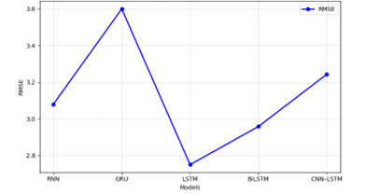
Figure 5- 4 RMSE Comparison among RNN, LSTM, GRU, BiLSTM, and CNN-LSTM
When compared with the persistence baseline (where tomorrow’s temperature is assumed to be the same as today’s), the LSTM demonstrates superior performance—particularly around turning points and transitional periods, where the baseline typically struggles. These results align with the validation trends discussed in Section 5.3, confirming that the model selected through validation generalizes effectively to unseen data.
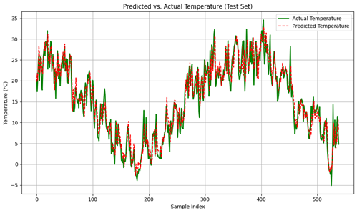
Figure 5- 5 Predicted vs. Actual Temperature (Test Set)
Overall, the evaluation supports the use of the LSTM model in this study, as it achieves a strong balance between accuracy, consistency, and generalization, outperforming other candidate models under the same data processing and hyperparameter settings.

5.6 Key Observations
From the overall experimental results and evaluation analysis, several important observations can be drawn regarding model behavior, data characteristics, and system performance.
First, among all tested architectures—RNN, LSTM, GRU, BiLSTM, and CNN-LSTM—the LSTM model consistently delivered the best generalization on the held-out test period. Its performance advantage is mainly due to the cell-state and gating mechanisms that allow it to retain long-term temporal dependencies in weather sequences. The BiLSTM and CNN-LSTM models showed competitive accuracy on the validation set but exhibited slightly higher variance and overfitting tendencies during later epochs.
Second, the multi-sensor feature combination significantly improved forecasting accuracy compared to single-variable (temperature-only) experiments. Including humidity, wind speed, radiation, and pressure enabled the model to capture correlated atmospheric patterns, resulting in lower RMSE and higher R² values. This demonstrates that sensor fusion enhances contextual understanding of climate dynamics.
Third, the persistence baseline produced reasonable short-term accuracy but failed to follow rapid temperature fluctuations or nonlinear patterns. This confirms that deep recurrent models outperform simple temporal extrapolation, especially when complex seasonal and cross-sensor relationships exist.
Fourth, careful data preprocessing and leakage control proved critical. The chronological train-validation-test split and train-only scaling ensured realistic performance estimation. When random shuffling was tested for comparison, validation scores improved artificially, verifying that chronological order must be preserved for honest evaluation.
Fifth, hyperparameter tuning and early stopping strongly influenced stability. Models trained with adaptive learning-rate scheduling converged faster and avoided oscillation. Dropout and L2 regularization successfully mitigated overfitting without degrading prediction precision.
Finally, the Flask-based deployment demonstrated that the trained model can be operationalized for real-time use. The interface accepted both manual input and CSV uploads and returned predictions within seconds, confirming the system’s practicality and scalability for web-based applications.
Overall, these observations validate that combining multi-sensor data, sequence-aware architectures, and disciplined preprocessing yields a robust and interpretable climate-forecasting pipeline ready for real-world deployment.

5.7 Visualization of Results
As illustrated in Figure 5.4, the plotted trajectories of true and predicted temperatures across consecutive time steps move closely together. The two lines follow similar seasonal patterns and short-term fluctuations, showing that the model successfully learns both long-term trends and short-term variations in temperature.
Most deviations occur during sharp temperature transitions, such as sudden warm-ups or cool-downs, which are naturally difficult for one-step forecasting models. Even in these cases, the LSTM’s predictions quickly realign with the actual temperature path, demonstrating resilience and adaptability.
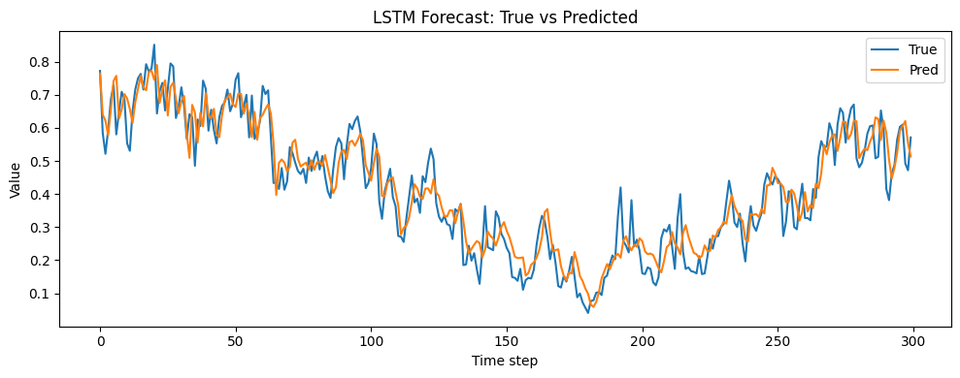
Figure 5- 6 LSTM Forecast – True vs. Predicted Temperature Over Time
These visual results complement the quantitative metrics by confirming that the deployed model performs reliably across both steady and rapidly changing weather conditions.

Chapter 6 Conclusion and Future Work

6.1 Summary of Findings
This research successfully developed and evaluated a Climate Forecasting System Based on Deep Learning and Multi-Sensors, designed to improve the precision and reliability of short-term temperature prediction. The system integrates multiple environmental parameters temperature, humidity, pressure, radiation, precipitation, and wind speed into a unified dataset. This multi-sensor configuration enabled the deep learning models to capture complex interdependencies among atmospheric variables, leading to more robust and accurate climate forecasts
The experimental results demonstrated that, among the tested architectures (RNN, GRU, BiLSTM, CNN–LSTM, and LSTM), the LSTM model achieved the best overall performance, producing the lowest Mean Absolute Error (MAE) and Root Mean Square Error (RMSE), and the highest Coefficient of Determination (R²). These results confirmed that the LSTM’s gated memory units are particularly effective for capturing long-term dependencies in time-series data, a critical capability for climate forecasting tasks.
Additionally, the study validated that data preprocessing and leakage control play a vital role in ensuring fair model evaluation. Chronological splitting and normalization using only the training data prevented data leakage and improved model generalization. Early stopping and adaptive learning rate scheduling further stabilized the training process, preventing overfitting and optimizing convergence speed.
The system’s final stage involved deploying the best-performing LSTM model through a Flask-based web application, integrating HTML, CSS, Bootstrap, and JavaScript for an interactive interface. The application supports both manual input and CSV file uploads, producing real-time predictions and visual outputs. This demonstrates the system’s potential for operational climate monitoring, data-driven decision support, and real-world environmental applications.
In conclusion, this work established an end-to-end climate forecasting pipeline that combines deep learning, multi-sensor data fusion, and web-based deployment. The proposed framework proved effective, scalable, and adaptable, offering a scientifically grounded and practically deployable solution for short-term climate prediction and environmental data analysis.

6.2 Practical Implications
Although the proposed climate forecasting system achieved promising results and demonstrated strong predictive performance, several limitations remain that could be addressed in future work.
First, the study was conducted using a limited regional dataset, which may restrict the model’s generalization to other geographic areas with different climate characteristics. Expanding the dataset to include multiple regions and longer time spans would improve robustness and global applicability.
Second, while the LSTM model effectively captures temporal dependencies, it may not fully model highly complex spatial–temporal interactions that exist in large-scale atmospheric systems. Incorporating spatial data from satellite or radar imagery could enhance the system’s ability to capture such patterns.
Third, the model was trained using a fixed set of meteorological variables. Although these features were sufficient for predicting temperature, additional environmental parameters such as soil moisture, evaporation rate, or solar index could further improve prediction accuracy.
Fourth, due to computational and time constraints, hyperparameter tuning and architecture exploration were performed within a limited range. More extensive optimization using automated search techniques such as Bayesian optimization or grid search may yield better results.
Lastly, while the system has been successfully deployed as a Flask-based web application, its usability and performance under large-scale, real-time conditions were not fully tested. Integration with cloud-based services and performance evaluation under high user loads remain areas for future improvement.
Despite these limitations, the system provides a strong foundation for accurate and practical climate forecasting and can be further developed to address broader and more complex forecasting challenges.

6.3 Limitations
Although the proposed climate forecasting system achieved promising results and demonstrated strong predictive performance, several limitations remain that could be addressed in future work.
First, the study was conducted using a limited regional dataset, which may restrict the model’s generalization to other geographic areas with different climate characteristics. Expanding the dataset to include multiple regions and longer time spans would improve robustness and global applicability.
Second, while the LSTM model effectively captures temporal dependencies, it may not fully model highly complex spatial–temporal interactions that exist in large-scale atmospheric systems. Incorporating spatial data from satellite or radar imagery could enhance the system’s ability to capture such patterns.
Third, the model was trained using a fixed set of meteorological variables. Although these features were sufficient for predicting temperature, additional environmental parameters such as soil moisture, evaporation rate, or solar index could further improve prediction accuracy.
Fourth, due to computational and time constraints, hyperparameter tuning and architecture exploration were performed within a limited range. More extensive optimization using automated search techniques such as Bayesian optimization or grid search may yield better results.
Lastly, while the system has been successfully deployed as a Flask-based web application, its usability and performance under large-scale, real-time conditions were not fully tested. Integration with cloud-based services and performance evaluation under high user loads remain areas for future improvement.
Despite these limitations, the system provides a strong foundation for accurate and practical climate forecasting and can be further developed to address broader and more complex forecasting challenges.

6.4 Future Improvements
Building on the current results, several directions are planned to further enhance the performance, scalability, and practical use of the proposed climate forecasting system.
First, the model can be improved by incorporating larger and more diverse datasets from different regions and climate zones. Expanding the training data to include global or multi-source observations will enable the model to generalize better and adapt to varying environmental conditions.
Second, future work will focus on integrating advanced deep learning architectures, such as Attention-based LSTM, Transformer networks, or ConvLSTM with spatial encoding, to better capture complex spatial–temporal dependencies in climate data. These models may significantly improve long-term forecasting accuracy and interpretability.

Third, automated hyperparameter optimization techniques, such as grid search or Bayesian optimization, will be applied to fine-tune model parameters more efficiently and achieve optimal performance with reduced manual effort.
Fourth, the web deployment can be expanded into a cloud-based system with a scalable backend and database support. This would allow real-time data ingestion, faster computation, and multi-user access through an interactive dashboard.
Additionally, improvements in the user interface and visualization components will make the system more user-friendly for researchers, students, and decision-makers. Future versions could include interactive maps, predictive trend analysis, and downloadable climate reports.
Finally, integrating explainable AI (XAI) techniques will help users understand how different environmental features influence temperature predictions, improving model transparency and trustworthiness.
Overall, these planned improvements aim to make the system more accurate, efficient, and scalable, contributing to the ongoing development of intelligent and practical climate forecasting tools.

Acknowledgement
First and foremost, I would like to express my deepest gratitude to Almighty Allah for granting me the strength, patience, and determination to successfully complete this thesis. Without His blessings and guidance, this accomplishment would not have been possible.
I extend my heartfelt appreciation to my supervisor, He Gang, for his invaluable guidance, encouragement, and continuous support throughout the research. His insightful feedback and constructive suggestions have been instrumental in shaping the direction and quality of this work.
My sincere thanks also go to the School of Software Engineering, Southwest University of Science and Technology (SWUST), for providing me with the necessary facilities, resources, and academic environment to conduct this research effectively.
I am profoundly grateful to my teachers and mentors who have enriched my academic journey with their knowledge and wisdom. Their teachings have inspired me to explore and grow in the field of Artificial Intelligence and Machine Learning.
Special thanks are due to my friends and colleagues for their cooperation, discussions, and moral support throughout the study. Their encouragement helped me stay motivated and overcome many challenges during this project.
Finally, I would like to express my deepest appreciation to my beloved family for their unconditional love, prayers, and unwavering support. Their patience and belief in me have been my greatest source of strength and inspiration.

References
- Jha, M. K., & Dev, M. (2024). Impacts of climate change. In Smart internet of things for environment and healthcare (pp. 139-159). Cham: Springer Nature Switzerland.
- Jaber, M. M., Ali, M. H., Abd, S. K., Jassim, M. M., Alkhayyat, A., Aziz, H. W., & Alkhuwaylidee, A. R. (2022). Predicting climate factors based on big data analytics based agricultural disaster management. Physics and Chemistry of the Earth, Parts A/B/C, 128, 103243.
- Jaber, M. M., Ali, M. H., Abd, S. K., Jassim, M. M., Alkhayyat, A., Aziz, H. W., & Alkhuwaylidee, A. R. (2022). Predicting climate factors based on big data analytics based agricultural disaster management. Physics and Chemistry of the Earth, Parts A/B/C, 128, 103243
- Chen, L., Han, B., Wang, X., Zhao, J., Yang, W., & Yang, Z. (2023). Machine learning methods in weather and climate applications: A survey. Applied Sciences, 13(21), 12019
- Blasch, E., Pham, T., Chong, C. Y., Koch, W., Leung, H., Braines, D., & Abdelzaher, T. (2021). Machine learning/artificial intelligence for sensor data fusion–opportunities and challenges. IEEE aerospace and electronic systems magazine, 36(7), 80-93
- Krivoguz, D., Ioshpa, A., Chernyi, S., Zhilenkov, A., Kustov, A., Zinchenko, A., ... & Tsareva, P. (2024). Enhancing long-term air temperature forecasting with deep learning architectures. Journal of Robotics and Control (JRC), 5(3), 706-716.
- Sahoo, S. (2024). Sensor Fusion and Virtual Sensor Design for Enhanced Multi-Sensor Data Accuracy in Autonomous Systems. International Journal on Smart & Sustainable Intelligent Computing, 1(2), 21-39.
- Eddamiri, S., Bassine, F. Z., Hakam, O., Kambiet, P. L. K., & Chehbouni, A. (2025). Applications of artificial intelligence for forecasting and managing extremes. In Climate Change and Rainfall Extremes in Africa (pp. 91-113). Elsevier.
- Chen, L., Han, B., Wang, X., Zhao, J., Yang, W., & Yang, Z. (2023). Machine learning methods in weather and climate applications: A survey. Applied Sciences, 13(21), 12019.
- Jagannathan, K., Pathak, T. B., & Doll, D. (2023). Are long-term climate projections useful for on-farm adaptation decisions?. Frontiers in Climate, 4, 1005104.
- Khusheef, A. S., Shahbazi, M., & Hashemi, R. (2024). Deep learning-based multi-sensor fusion for process monitoring: application to fused deposition modeling. Arabian Journal for Science and Engineering, 49(8), 10501-10522.
- Chen, L., Han, B., Wang, X., Zhao, J., Yang, W., & Yang, Z. (2023). Machine learning methods in weather and climate applications: A survey. Applied Sciences, 13(21), 12019.
- Yu, M., Huang, Q., & Li, Z. (2024). Deep learning for spatiotemporal forecasting in Earth system science: a review. International Journal of Digital Earth, 17(1), 2391952.
- Chen, S., Long, G., Jiang, J., Liu, D., & Zhang, C. (2023). Foundation models for weather and climate data understanding: A comprehensive survey. arXiv preprint arXiv:2312.03014.
- Shiri, F. M., Perumal, T., Mustapha, N., & Mohamed, R. (2023). A comprehensive overview and comparative analysis on deep learning models: CNN, RNN, LSTM, GRU. arXiv preprint arXiv:2305.17473.
- De Perez, E. C., Berse, K. B., Depante, L. A. C., Easton-Calabria, E., Evidente, E. P. R., Ezike, T., ... & Van Sant, C. (2022). Learning from the past in moving to the future: invest in communication and response to weather early warnings to reduce death and damage. Climate Risk Management, 38, 100461.
- Rinaldi, G., Theodorakos, K., Garcia, F. C., Agudelo, O. M., & De Moor, B. (2025). DSS4EX: A Decision Support System framework to explore Artificial Intelligence pipelines with an application in time series forecasting. Expert Systems with Applications, 269, 126421.
- Trevena, L. J., Bonner, C., Okan, Y., Peters, E., Gaissmaier, W., Han, P. K., ... & Zikmund-Fisher, B. J. (2021). Current challenges when using numbers in patient decision aids: advanced concepts. Medical Decision Making, 41(7), 834-847.
- Qiu, H., Li, T., & Zhang, B. (2024). The impact of climate change on the earth system and its simulation predictions: Progress, challenges, and future directions. Geographical Research Bulletin, 3, 231-246.
- Olaoluwa, E. E., Durowoju, O. S., Orimoloye, I. R., Daramola, M. T., Ayobami, A. A., & Olorunsaye, O. (2022). Understanding weather and climate extremes. In Climate impacts on extreme weather (pp. 1-17). Elsevier.
- Kong, T., Kim, T., Jeon, J., Choi, J., Lee, Y. C., Park, N., & Kim, S. W. (2022, February). Linear, or non-linear, that is the question!. In Proceedings of the fifteenth ACM international conference on web search and data mining (pp. 517-525).
- Slater, L. J., Arnal, L., Boucher, M. A., Chang, A. Y. Y., Moulds, S., Murphy, C., ... & Zappa, M. (2023). Hybrid forecasting: blending climate predictions with AI models. Hydrology and earth system sciences, 27(9), 1865-1889.
- Chen, J., Chen, S., Fu, R., Li, D., Jiang, H., Wang, C., ... & Hicks, B. J. (2022). Remote sensing big data for water environment monitoring: Current status, challenges, and future prospects. Earth's Future, 10(2), e2021EF002289.
- Zafeiropoulou, M., Mentis, I., Sijakovic, N., Terzic, A., Fotis, G., Maris, T. I., ... & Ekonomou, L. (2022). Forecasting transmission and distribution system flexibility needs for severe weather condition resilience and outage management. Applied Sciences, 12(14), 7334.
- Zhang, Y., & Thorburn, P. J. (2022). Handling missing data in near real-time environmental monitoring: A system and a review of selected methods. Future Generation Computer Systems, 128, 63-72.
- Ioannidis, J. P., Cripps, S., & Tanner, M. A. (2022). Forecasting for COVID-19 has failed. International journal of forecasting, 38(2), 423-438.
- Yadav, V. (2025). Predictive Analytics for Adaptive Web Interfaces Enhancing User Experience through Time Series Forecasting. International Explore Journal of Computer Science and Applications, 3(1), 18-32.
- Ren, X., Li, X., Ren, K., Song, J., Xu, Z., Deng, K., & Wang, X. (2021). Deep learning-based weather prediction: a survey. Big Data Research, 23, 100178.
- Uluocak, I., & Bilgili, M. (2024). Daily air temperature forecasting using LSTM-CNN and GRU-CNN models. Acta Geophysica, 72(3), 2107-2126.
- Ren, X., Li, X., Ren, K., Song, J., Xu, Z., Deng, K., & Wang, X. (2021). Deep learning-based weather prediction: a survey. Big Data Research, 23, 100178.
- Sebestyén, V., Czvetkó, T., & Abonyi, J. (2021). The applicability of big data in climate change research: The importance of system of systems thinking. Frontiers in Environmental Science, 9, 619092.
- Rivera, A., Ponce, P., Mata, O., Molina, A., & Meier, A. (2023). Local weather station design and development for cost-effective environmental monitoring and real-time data sharing. Sensors, 23(22), 9060.
- Zhang, C., Bengio, S., Hardt, M., Recht, B., & Vinyals, O. (2021). Understanding deep learning (still) requires rethinking generalization. Communications of the ACM, 64(3), 107-115.
- Shiri, F. M., Perumal, T., Mustapha, N., & Mohamed, R. (2023). A comprehensive overview and comparative analysis on deep learning models: CNN, RNN, LSTM, GRU. arXiv preprint arXiv:2305.17473.
- Barrera-Animas, A. Y., Oyedele, L. O., Bilal, M., Akinosho, T. D., Delgado, J. M. D., & Akanbi, L. A. (2022). Rainfall prediction: A comparative analysis of modern machine learning algorithms for time-series forecasting. Machine Learning with Applications, 7, 100204.
- Gibson, P. B., Chapman, W. E., Altinok, A., Delle Monache, L., DeFlorio, M. J., & Waliser, D. E. (2021). Training machine learning models on climate model output yields skillful interpretable seasonal precipitation forecasts. Communications Earth & Environment, 2(1), 159.
- Bustillo, A., Reis, R., Machado, A. R., & Pimenov, D. Y. (2022). Improving the accuracy of machine-learning models with data from machine test repetitions. Journal of Intelligent Manufacturing, 33(1), 203-221.
- Chicco, D., Warrens, M. J., & Jurman, G. (2021). The coefficient of determination R-squared is more informative than SMAPE, MAE, MAPE, MSE and RMSE in regression analysis evaluation. Peerj computer science, 7, e623.
- Aljawarneh, S., Lara, J. A., & Yassein, M. B. (2023). A visual big data system for the prediction of weather-related variables: Jordan-Spain case study. Multimedia Tools and Applications, 82(9), 13103-13139.
- Brunet, G., Parsons, D. B., Ivanov, D., Lee, B., Bauer, P., Bernier, N. B., ... & Yu, R. (2023). Advancing weather and climate forecasting for our changing world. Bulletin of the American Meteorological Society, 104(4), E909-E927.
- Seneviratne, S. I., Zhang, X., Adnan, M., Badi, W., Dereczynski, C., Luca, A. D., ... & Allan, R. (2021). Weather and climate extreme events in a changing climate.
- Yu, Z., Razzaq, A., Rehman, A., Shah, A., Jameel, K., & Mor, R. S. (2022). Disruption in global supply chain and socio-economic shocks: a lesson from COVID-19 for sustainable production and consumption. Operations Management Research, 15(1), 233-248.
- Jain, H., Dhupper, R., Shrivastava, A., Kumar, D., & Kumari, M. (2023). AI-enabled strategies for climate change adaptation: protecting communities, infrastructure, and businesses from the impacts of climate change. Computational Urban Science, 3(1), 25.
- Akhtar, S., Shahzad, S., Zaheer, A., Ullah, H. S., Kilic, H., Gono, R., ... & Leonowicz, Z. (2023). Short-term load forecasting models: A review of challenges, progress, and the road ahead. Energies, 16(10), 4060.
- Usmani, U. A., Aziz, I. A., Jaafar, J., & Watada, J. (2024). Deep Learning for Anomaly Detection in Time-Series Data: An Analysis of Techniques, Review of Applications, and Guidelines for Future Research. IEEE Access.
- Selvam, A. P., & Al-Humairi, S. N. S. (2025). Environmental impact evaluation using smart real-time weather monitoring systems: a systematic review. Innovative Infrastructure Solutions, 10(1), 1-24.
- Recker, J. (2021). Scientific research in information systems: a beginner's guide. Springer Nature.
- Fathi, M., Haghi Kashani, M., Jameii, S. M., & Mahdipour, E. (2022). Big data analytics in weather forecasting: A systematic review. Archives of Computational Methods in Engineering, 29(2), 1247-1275.
- Blasch, E., Pham, T., Chong, C. Y., Koch, W., Leung, H., Braines, D., & Abdelzaher, T. (2021). Machine learning/artificial intelligence for sensor data fusion–opportunities and challenges. IEEE aerospace and electronic systems magazine, 36(7), 80-93.
- Van Merriënboer, J. J., Kirschner, P. A., & Frèrejean, J. (2024). Ten steps to complex learning: A systematic approach to four-component instructional design. Routledge.
- Marsh, B., Sadka, A. H., & Bahai, H. (2022). A critical review of deep learning-based multi-sensor fusion techniques. Sensors, 22(23), 9364.
- Brunet, G., Parsons, D. B., Ivanov, D., Lee, B., Bauer, P., Bernier, N. B., ... & Yu, R. (2023). Advancing weather and climate forecasting for our changing world. Bulletin of the American Meteorological Society, 104(4), E909-E927.
- Wellyantama, P., & Soekirno, S. (2021, February). Temperature, pressure, relative humidity and rainfall sensors early error detection system for automatic weather station (AWS) with artificial neural network (ANN) backpropagation. In Journal of Physics: Conference Series (Vol. 1816, No. 1, p. 012056). IOP Publishing.
- Chen, L., Han, B., Wang, X., Zhao, J., Yang, W., & Yang, Z. (2023). Machine learning methods in weather and climate applications: A survey. Applied Sciences, 13(21), 12019.
- Ayiah-Mensah, F., Bosson-Amedenu, S., Baah, E. M., & Addor, J. A. (2025). Advancements in seasonal rainfall forecasting: A seasonal auto-regressive integrated moving average model with outlier adjustments for Ghana's Western Region. Scientific African, 28, e02632.
- Garrett, K. A., Nita, M., De Wolf, E. D., Esker, P. D., Gomez-Montano, L., & Sparks, A. H. (2021). Plant pathogens as indicators of climate change. In Climate change (pp. 499-513). Elsevier.
- Donadio, L., Fang, J., & Porté-Agel, F. (2021). Numerical weather prediction and artificial neural network coupling for wind energy forecast. Energies, 14(2), 338.
- Shah, J. H. (2022). 5G-Enabled IoT Mesh for Real-Time Control and Predictive Maintenance. International Journal of Scientific Research in Computer Science, Engineering and Information Technology, 593-605.
- Strielkowski, W., Vlasov, A., Selivanov, K., Muraviev, K., & Shakhnov, V. (2023). Prospects and challenges of the machine learning and data-driven methods for the predictive analysis of power systems: A review. Energies, 16(10), 4025.
- Singh, G., Sharma, A., Vishwakarma, P., & Gaur, M. (2024). Revealing non-linear trends and patterns in weather data through regression analysis approach. In Artificial Intelligence and Information Technologies (pp. 50-56). CRC Press.
- Lim, B., & Zohren, S. (2021). Time-series forecasting with deep learning: a survey. Philosophical Transactions of the Royal Society A, 379(2194), 20200209.
- Sarker, I. H. (2021). Deep learning: a comprehensive overview on techniques, taxonomy, applications and research directions. SN computer science, 2(6), 1-20.
- Ren, X., Li, X., Ren, K., Song, J., Xu, Z., Deng, K., & Wang, X. (2021). Deep learning-based weather prediction: a survey. Big Data Research, 23, 100178.
- Zargar, S. (2021). Introduction to sequence learning models: RNN, LSTM, GRU. Department of Mechanical and Aerospace Engineering, North Carolina State University, 37988518.
- Krivoguz, D., Ioshpa, A., Chernyi, S., Zhilenkov, A., Kustov, A., Zinchenko, A., ... & Tsareva, P. (2024). Enhancing long-term air temperature forecasting with deep learning architectures. Journal of Robotics and Control (JRC), 5(3), 706-716.
- Huang, R., Wei, C., Wang, B., Yang, J., Xu, X., Wu, S., & Huang, S. (2022). Well performance prediction based on Long Short-Term Memory (LSTM) neural network. Journal of Petroleum Science and Engineering, 208, 109686.
- Lim, B., & Zohren, S. (2021). Time-series forecasting with deep learning: a survey. Philosophical Transactions of the Royal Society A, 379(2194), 20200209.
- ArunKumar, K. E., Kalaga, D. V., Kumar, C. M. S., Kawaji, M., & Brenza, T. M. (2021). Forecasting of COVID-19 using deep layer recurrent neural networks (RNNs) with gated recurrent units (GRUs) and long short-term memory (LSTM) cells. Chaos, Solitons & Fractals, 146, 110861.
- Ahmed, A. M., Deo, R. C., Raj, N., Ghahramani, A., Feng, Q., Yin, Z., & Yang, L. (2021). Deep learning forecasts of soil moisture: convolutional neural network and gated recurrent unit models coupled with satellite-derived MODIS, observations and synoptic-scale climate index data. Remote Sensing, 13(4), 554.
- Khan, M., Wang, H., Riaz, A., Elfatyany, A., & Karim, S. (2021). Bidirectional LSTM-RNN-based hybrid deep learning frameworks for univariate time series classification. The Journal of Supercomputing, 77(7), 7021-7045.
- Montaha, S., Azam, S., Rafid, A. R. H., Hasan, M. Z., Karim, A., & Islam, A. (2022). Timedistributed-cnn-lstm: A hybrid approach combining cnn and lstm to classify brain tumor on 3d mri scans performing ablation study. IEEE Access, 10, 60039-60059.
- Zhang, Y., Zhang, B., Shen, C., Liu, H., Huang, J., Tian, K., & Tang, Z. (2024). Review of the field environmental sensing methods based on multi-sensor information fusion technology. International Journal of Agricultural and Biological Engineering, 17(2), 1-13.
- Sahoo, S. (2024). Sensor Fusion and Virtual Sensor Design for Enhanced Multi-Sensor Data Accuracy in Autonomous Systems. International Journal on Smart & Sustainable Intelligent Computing, 1(2), 21-39.
- Lalwani, P., & Ganeshan, R. (2024). A novel CNN-BiLSTM-GRU hybrid deep learning model for human activity recognition. International Journal of Computational Intelligence Systems, 17(1), 278.
- Sahoo, S. (2024). Sensor Fusion and Virtual Sensor Design for Enhanced Multi-Sensor Data Accuracy in Autonomous Systems. International Journal on Smart & Sustainable Intelligent Computing, 1(2), 21-39.
- PlÖtz, T. (2021). Applying machine learning for sensor data analysis in interactive systems: Common pitfalls of pragmatic use and ways to avoid them. ACM Computing Surveys (CSUR), 54(6), 1-25.
- Chen, L., Han, B., Wang, X., Zhao, J., Yang, W., & Yang, Z. (2023). Machine learning methods in weather and climate applications: A survey. Applied Sciences, 13(21), 12019.
- Liu, Z., Xiao, G., Liu, H., & Wei, H. (2022). Multi-sensor measurement and data fusion. IEEE Instrumentation & Measurement Magazine, 25(1), 28-36.
- Singh, M., Kumar, B., Rao, S., Gill, S. S., Chattopadhyay, R., Nanjundiah, R. S., & Niyogi, D. (2021). Deep learning for improved global precipitation in numerical weather prediction systems. arXiv preprint arXiv:2106.12045.
- Liu, K., Yu, Q., Yuan, Z., Yang, Z., & Shu, Y. (2021). A systematic analysis for maritime accidents causation in Chinese coastal waters using machine learning approaches. Ocean & Coastal Management, 213, 105859.
- J. Doe, “Klein Tank, A.M.G. and Coauthors, 2002. Daily dataset of 20th-century surface air temperature and precipitation series for the European Climate Assessment. Int. J. of Climatol., 22, 1441-1453. Data and metadata available at http://www.ecad.eu” Kaggle, 2023. [Online]. Available: https://www.kaggle.com/datasets/thedevastator/weather-prediction

